MINISTRY OF EDUCATION AND TRAINING

**SAIGON INTERNATIONAL UNIVERSITY**



**PROJECT REPORT**

**OBJECT-ORIENTED PROGRAMMING (OOP)**

**SCHOOL YEAR 2024-2025**

**TOPIC NAME:**

**OLYMPIC GAMES MEDAL ANALYZER**

**MAJOR**: **INFORMATION TECHNOLOGY**

Class: 24CNTT

Project Leader: Nguyen Duy Phuc

Instructor: **Dr. Le Ngoc Hieu**

**Ho Chi Minh City, May 2025**

**PHIẾU CHẤM**

Họ và tên SV1: Nguyễn Duy Phúc……………………………… Lớp: 24CNTT……

Tên Đồ án/Tiểu luận:

**OLYMPIC GAMES MEDAL ANALYZER**

**Đánh giá**

|  |  |  |  |  |
| --- | --- | --- | --- | --- |
| **TT** | **Tiêu chí** | **Thang điểm** | **Điểm chấm** | **Ghi chú** |
| 1 | ***Hình thức trình bày:***  - Trình bày đúng quy định hướng dẫn (font, số trang, mục lục, bảng biểu, danh mục tài liệu tham khảo …).  - Không lỗi chính tả, lỗi đánh máy, lỗi trích dẫn tài liệu tham khảo.  - Trình bày đẹp, văn phong sáng, không tối nghĩa. |  |  |  |
| 2 | ***Nội dung*** | | | |
| Chương 1 |  |  |  |
| Chương 2 |  |  |  |
| Chương 3 |  |  |  |
| Chương 4 |  |  |  |
| Chương 5 |  |  |  |
| 3 | **TỔNG ĐIỂM** | |  |  |

**Điểm chữ: ………………………………………… (Làm tròn đến 1 số thập phân)**

**Giảng viên**

# **TABLE OF CONTENTS**

**TABLE OF CONTENTS** i

**LIST OF TABLES, PHOTOS** iv

**LIST OF ABBREVIATIONS** v

**PREFACE** 1

**1. Reasons for choosing a topic** 1

**2. History of Problem Research** 1

**3. Objectives and tasks of the study** 3

**3.1. Purpose of the study** 3

**3.2. Research tasks** 4

3.2.1. Context research tasks and application requirements 4

3.2.2. Survey and selection of development technology 4

3.2.3. Java Desktop Application Development 5

3.2.4. Evaluate the effectiveness and scalability of the application 5

**4. Subjects and scope of research** 7

**4.1 Object of study** 7

**4.2 Scope of study** 7

**5. Research Methods** 8

**5.1. Theoretical research methods** 8

**5.2. Experimental methods** 9

**6. Structure of the project:** 11

**CONTENT** 12

**Chapter 1: Theoretical basis and research status** 12

**1.1. Scientific basis** 12

1.1.1. Overview of object-oriented programming 12

1.1.2. JavaFX Technology in Desktop Application Development 13

1.1.3. MySQL and SQL Database Administration System 14

1.1.4. Data Structures and Java Collections Framework 14

1.1.5. JFreeChart Library and Data Visualization Principles 15

**1.2. Research status** 16

1.2.1. The current state of modern technology 16

1.2.2. Analysis of similar sports data analysis applications and solutions 17

**Chapter 2: Solution Proposal and Analysis of Application Design** 19

**2.1. Proposed solutions** 19

2.1.1. General model 19

2.1.2. Functional requirements 21

2.1.2. Non-functional requests 24

**2.2. System Design Analysis and User Interface** 25

2.2.1. System Architecture 25

2.2.2. UI Design Analysis 27

**2.3. System operation diagram and interface** 31

2.3.1. Use Case Diagram 31

2.3.2 Login Flow/ Home Page 33

2.3.3 Key Data Management (Olympic Medal) 36

2.3.4 User Management 38

2.3.5 Statistics and charts 40

**2.4. MySQL Database Structure** 43

2.4.1. ERD Model 43

2.4.2. Description of the data table 43

2.4.3. Binding and Relationship 45

**Chapter 3: System Mechanism of Operation** 48

**3.1.** **Installing Layers and Software Packages** 48

3.1.1. Model Class 48

3.1.2. Lớp DAO (Data Access Object) 49

3.1.3. Service Class 51

3.1.4. Service Class 54

3.1.5. Utilities 56

**3.2. User authentication mechanism** 57

3.2.1. Login Session Management 57

3.2.2. Password encryption 59

3.2.3. Decentralize users 61

**3.3. Data management mechanism** 62

3.3.1. Connect to a database 62

3.3.2. CRUD 63

3.3.3. Java Collections in Data Management 64

**3.4. Chart display mechanism** 66

3.4.1. JFreeChart Integration 66

3.4.2. Bar Chart 67

3.4.3. Pie Chart 69

3.4.4. Pie Chart 69

**Chapter 4: Product Experimentation and Evaluation** 71

**4.1. Experimental process** 71

**4.1.1. Implementation environment** 71

**4.1.2. Test Scenarios** 72

**4.1.3. Assessment methods** 75

**4.2. Experimental results** 76

4.2.1. Login Test 76

4.2.2. Data Management Testing 76

4.2.3. Testing Statistics and Charts 77

4.2.4. Performance Testing 78

**4.3. Product Evaluation** 79

4.3.1. Advantages 79

4.3.2. Limitations 80

**CONCLUSION** 81

**REFERENCES** 83

# **LIST OF TABLES, PHOTOS**

Figure 1. 1. History of project commits 10

Figure 2. 1. General model 21

Figure 2. 2. Layering model 27

Figure 2. 3. Login screen 28

Figure 2. 4. Main Control Panel 28

Figure 2. 5. Medal management screen 29

Figure 2. 6. User management screen 29

Figure 2. 7. Event Management Screens 30

Figure 2. 8. Chart view screen 30

Figure 2. 9. Report view screen 31

Figure 2. 10. User Profile Screen 31

Figure 2. 11. Use Case diagram illustration 33

Figure 2. 12. Login/Home Flow 36

Figure 2. 13. Medal management flow 38

Figure 2. 14. User management flow 40

Figure 2. 15. Statistical and chart flows 43

Figure 2. 16. ERD Model 43

# **LIST OF ABBREVIATIONS**

|  |  |
| --- | --- |
| **Abbreviation** | **Explanation** |
| **TO** | **Auto Increment** |
| **API** | **Application Programming Interface** |
| **CRUD** | **Create, Read, Update, Delete** |
| **CSS** | **Cascading Style Sheets** |
| **DAO** | **Data Access Object** |
| **DB** | **Database** |
| **EARTH** | **Entity-Relationship Diagram** |
| **FXML** | **FX Markup Language (for JavaFX)** |
| **GUI** | **Graphical User Interface** |
| **GOES** | **Integrated Development Environment** |
| **JDBC** | **Java Database Connectivity** |
| **JDK** | **Java Development Kit** |
| **JRE** | **Java Runtime Environment** |
| **JVM** | **Java Virtual Machine** |
| **MVC** | **Model-View-Controller** |
| **NIGHT** | **National Olympic Committee** |
| **OOP** | **Object-Oriented Programming** |
| **THE** | **Operating System** |
| **PDF** | **Portable Document Format** |
| **HP** | **Primary Key** |
| **POJO** | **Plain Old Java Object** |
| **RDBMS** | **Relational Database Management System** |
| **SQL** | **Structured Query Language** |
| **UI** | **User Interface** |
| **UML** | **Unified Modeling Language** |
| **XML** | **Extensible Markup Language** |

**ABSTRACT TABLE OF THE PROJECT**

* **Project Title:** OLYMPIC GAMES MEDAL ANALYZER
* **Purpose:** To develop a comprehensive desktop application using Java, JavaFX, and JFreeChart for managing, analyzing, and visualizing Olympic medal data. The project aims to apply Object-Oriented Programming (OOP) principles effectively, utilize the Java Collections Framework, and ensure secure user authentication and data management with a MySQL database.
* **Research Method:** The project employed a combination of theoretical research and empirical development. Theoretical aspects involved studying OOP concepts, JavaFX for GUI development, MySQL database management, JFreeChart for data visualization, and Maven for project management. The empirical approach included iterative design and implementation of the application's modules (user management, data management, charting, reporting), utilizing FXML for UI structure and SceneBuilder for visual design. Development followed a structured approach with distinct layers for data access (DAO), business logic (Service), and presentation (Controller).
* **Main Results:** The primary outcome is a functional JavaFX desktop application, "Olympic Games Medal Analyzer." Key achievements include:
  + A secure user authentication system with hashed password storage (SHA-256) and role-based access control (Admin, Staff/Analyst).
  + Comprehensive CRUD (Create, Read, Update, Delete) functionalities for managing Olympic medal data and Olympic events (Admin only).
  + Dynamic data visualization capabilities using JFreeChart, offering bar charts (Top N countries), pie charts (medal distribution), and line charts (medal trends).
  + A reporting module to generate textual summaries of Olympic data.
  + A well-structured project adhering to OOP principles, with clear separation of concerns across model, DAO, service, and controller layers.
* **Significance:** This project serves as a practical tool for users interested in analyzing Olympic Games medal data, offering features for data management and insightful visualization. It demonstrates the effective application of Java technologies, OOP principles, and database interaction in building a robust desktop application. Furthermore, it provides a valuable learning experience and a reference for developing data-centric applications with JavaFX and JFreeChart.

# **PREFACE**

## **1. Reasons for choosing a topic**

In the context of increasingly strong digital transformation, sports data – especially from high-caliber events such as the Olympic Games – is not only highly informative but also an important source of information for analysis, research and communication. However, there is currently a lack of a centralized platform that allows users to easily manage, query, and visualize medal data by time, country, and event. The need to synthesize data from many discrete sources makes it difficult to compare and exploit global sports trends.

From that fact, the team decided to implement the project "**Olympic Games Medal Analyzer**" with the goal of building a desktop application using Java, supporting the management and analysis of Olympic medal data in an effective and intuitive way. The project applies object-oriented programming (OOP), exploits data structures in the Java Collections Framework, integrates statistical charts through the JFreeChart library, and ensures security through user authentication mechanisms.

Through this topic, the team not only hopes to provide a useful tool for journalists, analysts or sports fans, but also demonstrates the ability to apply programming knowledge to solve practical problems with high application value.

## **2. History of Problem Research**

The Olympic Games, with their long history and global scale, have always been a rich and fascinating source of data for researchers, sports analysts, and fans. The analysis of achievements and medal trends through the Games not only reflects the development of sports in each country but also shows changes in the world sports situation.

1. Early Stages and Manual Collection: In the early stages of the modern Olympics, data collection and analysis was mostly done manually. Journalists, sports historians and Olympic organizations store the results on papers and books. The analysis usually stops at a simple statistical level, listing the number of medals and the basic ranking. This process takes a lot of time, effort and is prone to errors.
2. The advent of computers and databases: With the development of computer technology and database systems in the second half of the 20th century, the storage and management of sports data became more efficient. Major sports organizations began to digitize records, creating the first electronic databases of competition results. This opens up more sophisticated querying and statistical capabilities, however, specialized analytical tools are still limited and mainly cater to professionals.
3. The explosion of the Internet and sports information websites: In the late 20th and early 21st century, the explosion of the Internet brought about a revolution in access to sports information. Countless websites and portals have been born, providing results, medal tables and analysis of the Olympics. Fans can easily search for information, however, the data is often presented in static form, and the ability of end-users to interact and customize analytics is limited. In-depth analyses are often still performed by experts or media organizations.
4. Trends in Dedicated Applications and Data Visualization: In recent years, noticing the growing need for deep and intuitive data analysis, many specialized applications and tools have been developed. Data visualization technologies such as dynamic charts and interactive maps are increasingly popular, making it easy for users to grasp complex information. However, many current solutions may be:

* Paid online service: Requires users to pay a fee to access advanced analytics features.
* Complex tools for professionals: Requires expertise in data analysis or programming.
* Mobile app with limited features: Focus on providing information quickly rather than the ability to analyze and manage data comprehensively.
* Lack of customization and local management: It is difficult for users to deeply customize analytics or manage datasets according to their own needs on a powerful desktop platform.

1. The need for a comprehensive and user-friendly desktop solution: From the above situation, it is clear that there is a need for a desktop application such as "Olympic Games Medal Analyzer". A tool that allows users to not only view data, but also be able to manage (CRUD), perform complex queries, and most importantly, visualize analyses in a flexible and meaningful way. Building this application in Java, combined with JavaFX for graphical user interface (GUI) and JFreeChart for charting, along with a powerful MySQL database, will meet this need. The application not only serves the purpose of information, but also a learning and value research tool, and demonstrates the ability to apply the principles of Object-Oriented Programming and modern software techniques to solve a practical problem.

## **3. Objectives and tasks of the study**

### **3.1. Purpose of the study**

* Build a comprehensive Olympic data analysis tool: Develop a powerful desktop application that allows users to manage, query, and analyze medal data from the Olympics efficiently and centrally.
* Visualize sports information visually and meaningfully: Apply the JFreeChart library to create diverse charts (columns, circles, lines), making it easy for users to capture trends, compare achievements, and discover valuable insights from medal data.
* Apply and demonstrate Object-Oriented Programming (OOP) principles and Java technologies: Demonstrate the ability to apply the core knowledge of Java, JavaFX, and object-oriented software design techniques to build a practical, well-structured, and easy-to-maintain application.
* Provide a user-friendly and accessible solution: An intuitive, easy-to-use user interface (GUI) design that allows even non-technical users to efficiently mine and analyze Olympic data.
* Create a valuable learning and reference resource: The product is not only an analytical tool but also a practical example of database integration, business logic processing, and data visualization in software development, serving the purpose of learning and research.

### **3.2. Research tasks**

* + 1. ***Context research tasks and application requirements***
* Analyze the current state of access and analyze Olympic data: Evaluate the existing methods and tools that users (from fans, journalists to sports analysts) are using to track and analyze Olympic medal performance. Identify limitations, gaps, and unmet needs.
* Identify your target audience and their needs: Categorize potential user groups (e.g., data administrators, analysts, regular users) and clarify each group's specific requirements for an Olympic data analytics tool.
* Collect and shape core functional requirements: Based on contextual analysis and user needs, identify the essential features of the application, including: medal data management (CRUD), user authentication and management, types of data analysis and visualization (charts, reports), and other ancillary features.
* Recommend critical non-functional requirements: Determine the criteria for performance, security, usability, ease of maintenance, and scalability of the application to ensure the quality and long-term success of the product.

#### **Survey and selection of development technology**

* Programming language and GUI: Java was chosen for its cross-platform, strong community, and rich ecosystem. JavaFX combines FXML and SceneBuilder to create a modern, intuitive, and easy-to-maintain interface.
* Databases: MySQL is used for its high performance, support for complex queries, and the ability to process large amounts of data. SQLyog supports efficient database management through a user-friendly graphical interface.
* Data visualization: JFreeChart was chosen for creating high-quality charts that are easy to integrate into JavaFX.
* Project management: Apache Maven supports dependency management and automating the build process, helping to standardize projects.
* Supporting technologies: Java Collections Framework for efficient data processing; OOP principles ensure that the source code is clear, easy to extend, and maintain.
  + 1. ***Java Desktop Application Development***
* The central mission of the project is to build a complete desktop application, called "Olympic Games Medal Analyzer", that is capable of interacting effectively with users and databases. The application is developed using the Java programming language, leveraging the power of the JavaFX platform combined with FXML and SceneBuilder to design an intuitive and user-friendly user interface (GUI).
* The development process will closely adhere to the principles of Object-Oriented Programming (OOP), including encapsulability, inheritance, polymorphism, and abstraction, in order to build a system that is clearly structured, easy to maintain, and extensible. Object classes (Models) will be designed to accurately map Olympic data entities.
* The application will connect to and manipulate the MySQL database, which is managed through the SQLyog tool. Data query and update operations (CRUD) will be performed through Data Access Object (DAO) layers, ensuring separation between the business logic and the data access layer.
* To visualize medal data, the JFreeChart library will be integrated, allowing the display of diverse statistical charts (columns, circles, lines), making it easy for users to grasp trends and analyze achievements.
* Throughout the development process, source code management, exception handling, and code quality assurance will be focused, aiming for a software product that is stable, efficient and fully meets the set requirements.
  + 1. ***Evaluate the effectiveness and scalability of the application***
* Performance Evaluation:
  + Functional testing: Verify the correctness and reliability of all core functions, including user management (CRUD), Olympic medal data management, data querying, and especially the ability to accurately create and display statistical chart types (columns, circle, line) using JFreeChart.
  + Performance Evaluation: Measures the response time of the system to key tasks such as querying data, loading charts, and CRUD operations, especially when working with large volumes of data across multiple Olympics.
  + User Experience (UX/UI): Gather feedback on ease of use, UI intuitiveness (designed using JavaFX and SceneBuilder), and smoothness of interaction.
  + Security: Check the effectiveness of user authentication mechanisms, password encryption (SHA-256), and access decentralization, ensuring data safety.
* Scalability Assessment:
  + Modularization Architecture: Analyze the project structure (model, knife, service, controller,...) to evaluate the ability to easily add new or modify functional modules without greatly affecting other components.
  + Ability to add new data: Evaluate the system's flexibility in receiving and processing data from new Olympics or other types of related sports data in the future.
  + Functional extensibility: Consider the potential to develop advanced features such as predictive analytics, more detailed comparisons between athletes/sports, or integration of external data sources.
  + Maintainability of the source code: Evaluate the quality of the source code based on standards (Java Coding Conventions), the clarity of comments, and the application of OOP principles to ensure that the source code is easy to understand, fix, and upgrade.

## **4. Subjects and scope of research**

### **4.1 Object of study**

* Olympic Medal Data: Includes detailed information on the number of medals (Gold, Silver, Bronze) of participating countries through different Olympics.
* Business process: Activities related to user management (authentication, decentralization), medal data management (CRUD), querying, statistics, and data visualization.
* Software development technology and techniques: Applying Object-Oriented Programming (OOP) principles, Java language, JavaFX technology for user interface, MySQL database management system for storing and retrieving data, and JFreeChart library for creating charts.
* Target Users: Includes Admins with full system management and Staff/Analysts with data access and analysis.

### **4.2 Scope of study**

* Function:
  + Build a basic login, logout and user profile management system with a decentralized mechanism.
  + Implement Olympic medal data management functions (Add, Watch, Edit, Delete) for the Olympics.
  + Developed a data visualization module, which allows to display basic statistical chart types (columns, circles, lines) of medal achievements.
  + Allows the creation of basic statistical reports based on medal data.
* Regarding technology:
  + The application is developed as desktop software using the Java language and the JavaFX platform.
  + The database administration system used is MySQL.
  + The JFreeChart library is integrated to serve the charting function.
  + Manage projects and libraries using Apache Maven.
* About the data:
  + Focus on medal data of countries at the Olympics that have been made available or can be collected publicly.
  + Do not delve into the detailed analysis of each athlete's performance or socio-economic factors affecting sports performance.
* About the platform:
  + The application is designed to work on popular desktop operating systems that support the Java Runtime Environment (JRE).

## **5. Research Methods**

### **5.1. Theoretical research methods**

* Object-Oriented Programming (OOP) with Java: Study the core tenets of OOP such as encapsulation, inheritance, polymorphism, and abstraction. Learn how to effectively apply object-oriented design principles to build a software system that is clearly structured, easy to maintain, and extensible.
* User Interface (GUI) Development with JavaFX and FXML: Study the architecture of JavaFX, how to use FXML and SceneBuilder to design an intuitive and user-friendly user interface. Learn about layouts, controls, and event handling mechanisms in JavaFX.
* Relational Database Management with MySQL: Study the concepts of relational databases, structured query language (SQL), and effective database design techniques. Learn how to use the SQLyog tool to administer and manipulate MySQL databases.
* Data Visualization with JFreeChart: Study the capabilities of the JFreeChart library in creating diverse chart types (columns, circles, lines) and how to integrate JFreeChart into the JavaFX application to visualize statistical data in a visual and meaningful way.
* Project and library management with Apache Maven: Learn how to use Maven to manage dependencies, automate the build process, and package applications.
* Data Structures and Algorithms (Java Collections Framework): Research and selection of appropriate data structures (ArrayList, HashMap, TreeMap,.. etc.) to efficiently store, retrieve and process data in the application.
* Application Security Principles: Research methods for user authentication, password encryption (SHA-256), and secure session management.

### **5.2. Experimental methods**

* **Prototyping and Incremental Development:** Starting from designing the core modules (user management, medal data management, graph display), then developing and testing one part at a time. Initial versions were built to test the feasibility of technical solutions and gather early feedback.
* **Module deployment:** Divide the application into clear functional modules (controller, service, dao, model, util,.. etc.) for easy management, parallel development, and integration.
* **Unit Testing and Integration Testing:** Perform testing of individual components (DAO, Service,.. etc.) and test the interaction between modules to ensure the correctness and stability of the system.
* **Optimize and Debug:** Continuously review and optimize your app's source code and performance. Use the IDE's debugger tools to identify and fix errors that arise during development.
* **Use development tools:** Leverage the features of the IDE (Eclipse), SceneBuilder to speed up development, and SQLyog to manage databases efficiently.

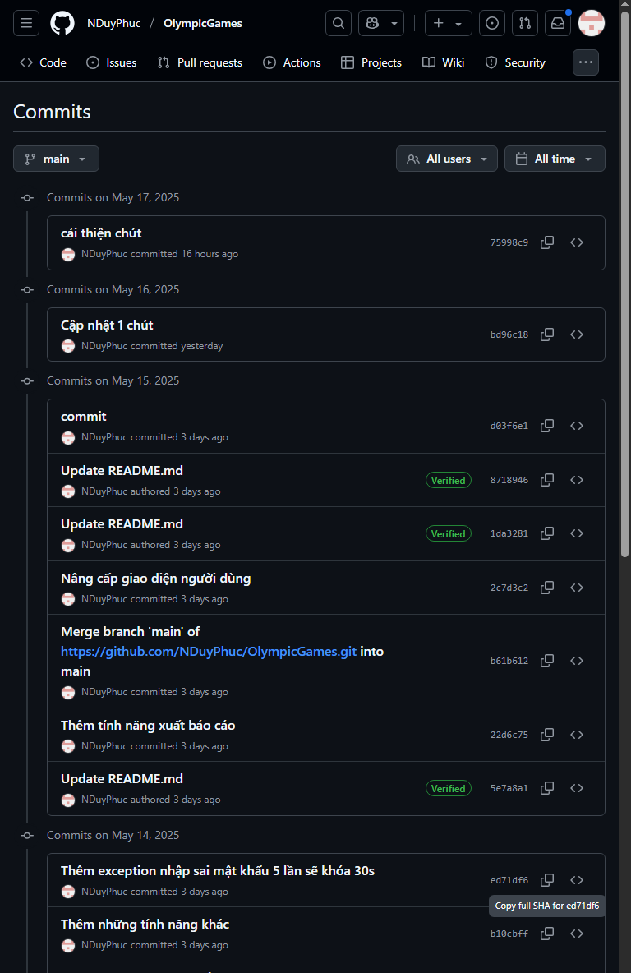

Figure 1. . History of project commits

## **6. Structure of the project:**

* Chapter 1: Theoretical basis and research status

Present the background knowledge of Object-Oriented Programming, JavaFX technology, MySQL database management system, data structures in Java, and JFreeChart library. At the same time, this chapter also examines the current state of existing sports data analysis tools and identifies the gaps that the topic aims to address.

* Chapter 2: Application Design Solutions and Analysis

Propose solutions to build applications, identify functional and non-functional requirements. Analyze and design the system architecture in detail, design the user interface (UI) through use case diagrams, flow diagrams for key functions. In particular, this chapter will describe in detail the MySQL database structure with the ERD model and describe the data tables.

* Chapter 3: System Mechanism of Operation

Describe in detail how the components in the app are implemented and worked. Including the installation of Model, DAO, Service, Controller and utility classes. Explain user authentication mechanisms, session management, password encryption, and decentralization. Demonstrates how to manage medal data (CRUD), the use of Java Collections, and how to display and interact with JFreeChart charts. Exception handling and optimization issues are also covered.

* Chapter 4: Product Experimentation and Evaluation

Present the process and experimental environment, test scenarios for key functions such as login, data management, and chart display. Analyze the experimental results, evaluate the advantages and limitations of the product and compare (if any) with similar solutions. Highlight new points and suggest potential development directions for the application in the future.

# **CONTENT**

## **Chapter 1: Theoretical basis and research status**

### **1.1. Scientific basis**

#### **1.1.1. Overview of object-oriented programming**

Object-Oriented Programming is a programming model based on the concept of "objects", which can contain data in the form of attributes and scripts in the form of methods. OOP provides a structured and modular approach to complex software design and development. The main principles of OOP that are fully applied in this project include:

* Encapsulation: Conceals the internal details of an object and only allows interaction through public interfaces. This helps protect data, reduce dependencies between components, and increase the maintainability of the source code. In the project, entity classes (Models) such as User, MedalEntry, and OlympicEvent will have private properties and are accessed through public getter/setter methods.
* Inheritance: Allows one class (subclass) to inherit properties and methods from another class (superclass). Inheritance helps reuse source code, creating an organized and easily scalable layer hierarchy. For example, it is possible to create a BaseDAO class that contains generic CRUD methods that specific DAO classes will inherit.
* Polymorphism: Allows objects of different classes to be processed through a common interface. Polymorphisms are often expressed by method overriding and method overloading. This increases the flexibility and adaptability of the system. For example, a ChartGenerator interface can be implemented by the BarChartGenerator and PieChartGenerator classes with the generateChart() method implemented differently.
* Abstraction: Focusing on the essential characteristics of an object and ignoring unnecessary details. Abstraction simplifies the design and understanding of the system. Abstract classes and interfaces are powerful tools for achieving abstraction.

The application of OOP helps build the "Olympic Games Medal Analyzer" application with an organized, easy-to-understand, easy-to-maintain, and highly scalable source code.

#### **1.1.2. JavaFX Technology in Desktop Application Development**

JavaFX is Oracle's next-generation multimedia software platform, designed to build and deploy Rich Internet Applications (RIAs) and rich desktop applications. JavaFX provides a comprehensive set of tools for developing modern, interactive, and high-performance user interfaces (GUIs). Notable features of JavaFX leveraged in the project include:

* **FXML (FX Markup Language):** An XML-based language for defining the user interface structure separately from the application logic. The use of FXML simplifies the UI design process, allowing designers and programmers to work independently and easily update the interface without compromising the Java source code. SceneBuilder is a visual aid in FXML design.
* **MVC (Model-View-Controller) model or variants:** JavaFX encourages the adoption of architectural patterns such as MVC, which provides a clear separation between data (Model), user interface (View - defined by FXML) and processing logic (Controller - Java classes associated with FXML). This increases the modularity and testability of the application.
* **Rich Controls:** JavaFX provides a diverse library of user interface components (controls) such as Button, Label, TextField, ComboBox, TableView, ListView, Spinner, ScrollPane, Pane, Canvas, etc.
* **CSS Styling:** JavaFX supports customization of the user interface through CSS (Cascading Style Sheets), allowing for the creation of apps that look beautiful, consistent, and on-brand.
* **Multi-Threading and Concurrency:** JavaFX has an efficient multi-threaded processing mechanism, ensuring that the user interface is always responsive even when performing time-consuming background tasks (e.g., querying databases, creating complex charts).
* **Graphics and Multimedia Integration:** JavaFX is capable of processing 2D and 3D graphics and integrating effects and animations smoothly, as demonstrated by the animation modules in the project.

#### **1.1.3. MySQL and SQL Database Administration System**

MySQL is a popular open-source relational database management system (RDBMS) that is known for its high performance, stability, and ease of use. In the "Olympic Games Medal Analyzer" project, MySQL was chosen as the place to store all data about users, Olympics and medal achievements.

* **Relational data model:** Data is organized into tables, each consisting of rows and columns. The relationships between tables are defined through primary keys and foreign keys, ensuring data integrity and consistency.
* **Structured Query Language (SQL):** SQL is the standard language for interacting with relational databases. SQL (SELECT, INSERT, UPDATE, DELETE) statements are used to query, add new, update, and delete data in tables.
* **Database Schema Design:** Includes defining entities, attributes, and relationships between them to create an optimal database schema, avoid data overload, and ensure query efficiency. The Entity-Relationship Diagram (ERD) is a useful tool in this phase.
* **Database Administration Tool (SQLyog):** SQLyog is a powerful MySQL administration tool that provides a graphical interface for easily designing tables, writing and executing SQL statements, managing users, and data backup/recovery.
* **Java Database Connectivity (JDBC):** The JDBC API is a Java standard for connecting and executing queries to databases. The DBConnectionManager class in the project will be responsible for managing this connection.

#### **1.1.4. Data Structures and Java Collections Framework**

The effective selection and use of data structures is critical to optimizing performance and managing data in an application. The Java Collections Framework (JCF) provides a set of pre-implemented interfaces and classes for common data structures.

* List (e.g. ArrayList, LinkedList): Used to store a set of objects in order. ArrayList is often used to store a list of MedalEntries taken from a database, an OlympicEvent list for a ComboBox, and so on.
* Map (e.g., HashMap, TreeMap): Used to store key-value pairs. HashMaps can be used to cache logged-in user information, or to prepare data for charts (e.g., Map<String, Integer> for medal numbers by country). TreeMap can be useful when data is needed to be sorted by key.
* Set (e.g., HashSet, TreeSet): Used to store a unique set of objects (non-duplicates).
* Sorting and search algorithms: JCF provides utilities for sorting (e.g., Collections.sort(), Comparator) and searching in collections, which helps to process data efficiently. For example, sort the medal list by total number of medals or by medal type.

#### **1.1.5. JFreeChart Library and Data Visualization Principles**

Data visualization is a powerful method for turning raw data sets into information that is easy to understand, easy to grasp, and meaningful. JFreeChart is a popular open-source Java library that offers the ability to create a wide range of high-quality 2D and 3D charts.

* **Chart types:** JFreeChart supports a variety of chart types such as Bar Chart, Pie Chart, Line Chart, Area Chart, XY Chart, etc.
  + **Bar Chart:** Suitable for comparing the number of medals (total, gold, silver, bronze) between countries in a particular Olympics, or comparing a country's achievements across different events.
  + **Pie Chart:** Useful for showing the proportion of medals (gold, silver, bronze) of a country in an Olympics, or to distribute the total number of medals by continent.
  + **Line Chart:** Ideal for tracking performance trends (e.g., total medals or gold medals) of one or more countries over consecutive Olympic Games.
* **Dataset:** JFreeChart uses Dataset objects (e.g., DefaultCategoryDataset for column/line charts, DefaultPieDataset for pie charts) to contain the data to be plotted. The ChartService class will be responsible for preparing these datasets from the data provided by the MedalService.
* **Chart Customization:** JFreeChart allows extensive customization of aspects of the chart such as titles, legends, colors, fonts, axis labels, and more to create professional and easy-to-read charts.
* **Integration with JavaFX:** Although JFreeChart is based on Swing, it can be embedded in a JavaFX application via the SwingNode class or by exporting the chart to an image and then displaying it in an ImageView. This project uses SwingNode to embed the ChartPanel.
* **Principles of effective data visualization:** Choosing the right type of chart, using the right colors, providing enough contextual information (titles, labels), and avoiding confusing viewers with too much detail are important factors for effective data visualization.

### **1.2. Research status**

#### **1.2.1. The current state of modern technology**

In recent years, information technology has come a long way, providing a variety of powerful tools and platforms for data collection, management, analysis, and visualization, including sports data:

* Desktop Application Development Platform: Java, with the support of JavaFX, remains a powerful and popular choice for building cross-platform desktop applications, which have a rich user interface and efficient data processing capabilities. Technologies such as .NET (C#), Python (with libraries such as Tkinter, PyQt) are also significant competitors.
* Database management systems: MySQL, PostgreSQL, SQL Server, and NoSQL database management systems (such as MongoDB) provide flexible data storage and query solutions that can accommodate large volumes of data from sporting events.
* Data visualization libraries: Besides JFreeChart for Java, there are many other powerful libraries such as Matplotlib, Seaborn (Python), D3.js (JavaScript), Tableau, Power BI (specialized BI tools) that allow the creation of diverse, interactive charts and dashboards.
* Development and project management tools: Modern IDEs (IntelliJ IDEA, Eclipse, VS Code), version management systems (Git, GitHub), and project management tools (Maven, Gradle) have become the standard, helping to optimize the software development process.

This situation shows that there are enough tools and technology platforms to build a quality Olympic data analysis application. However, choosing and integrating the right technologies to create an optimal solution that meets the needs of users is still a problem to be solved.

#### **1.2.2. Analysis of similar sports data analysis applications and solutions**

Currently, there are many sources of information and several applications that provide data and analysis on sporting events, including the Olympic Games:

* **Official sports information websites:** The websites of the International Olympic Committee (IOC), national Olympic committees, and major news outlets (ESPN, BBC Sport) provide up-to-date information on results, medal tables. However, the ability to customize analytics and visualizations is often limited.
* **Specialized mobile apps:** Some mobile apps provide information and statistics about the Olympics, often focusing on quick results updates and a mobile user experience.
* **Business Intelligence (BI) and general data analysis tools:** Tools such as Tableau, Power BI, Google Data Studio can be used to connect to Olympic data sources (if available as accessible) and create powerful analytics dashboards. However, they often require users to have BI expertise and are not always a pre-packaged solution for the typical end-user.
* **Research projects and open source:** Some researchers or the open-source community may have developed tools or scripts for analyzing Olympic data. However, they are often academic in nature or require technical skills to use.

## **Chapter 2: Solution Proposal and Analysis of Application Design**

### **2.1. Proposed solutions**

The "Olympic Games Medal Analyzer" application is proposed to be built as a desktop application using the Java programming language, with a user interface (GUI) designed using JavaFX and FXML (using SceneBuilder to support visual design). Medal data and user information will be stored and managed in a MySQL database (managed through SQLYog). The visualization of statistical data will be done using the JFreeChart library. The project will be managed and built using Apache Maven in the Eclipse development environment.

#### **2.1.1. General model**

The application is designed in a multi-layered architecture, close to the Model-View-Controller (MVC) model to ensure modularity, ease of maintenance and scalability:

1. **UI Layers (View - JavaFX & FXML):**
   * Responsible for displaying information and receiving interaction from users.
   * Built with FXML to define the interface structure and CSS (optional) to customize the interface.
   * SceneBuilder is used to visually design FXML files.
   * Integrate ChartPanel from JFreeChart to display charts in JavaFX Panes.
2. **Controller Layer (JavaFX Controllers):**
   * Handles events from the UI (e.g. button press, selecting an item from the ComboBox).
   * Interact with the Service class to request business logic processing and data retrieval.
   * Updated the UI based on the results returned from the Service class.
   * Controllers are associated with the corresponding FXML file via fx:controller.
3. **Service Class:**
   * Contains the main business logic of the application.
   * Coordinate operations between the Controller and the DAO.
   * Perform calculations, process data (e.g., calculate total medals, prepare data for charts).
   * Ví dụ: AuthService, MedalService, ChartService, ReportService.
4. **Data Access Object (DAO):**
   * Responsible for direct interaction with MySQL databases.
   * Provides CRUD (Create, Read, Update, Delete) methods for data entities.
   * Abstracting database access, the Service class doesn't need to know the details of how the database is queried.
   * Ví dụ: UserDAO, MedalDAO, OlympicEventDAO.
5. **Model Classes (POJOs):**
   * Represents data entities in the app (e.g., User, MedalEntry, OlympicEvent).
   * Plain Old Java Objects (POJOs) with private properties and getter/setter public methods.
6. **Database (MySQL):**
   * Store all of the app's data, including user information, Olympic information, and detailed medal data. SQLYog is used as a database administration tool.
7. **Library Management and Build Management (Maven):**
   * pom.xml will manage dependent libraries such as JavaFX, JFreeChart, MySQL Connector/J, Apache Commons Codec (for password hashing), and necessary plugins.

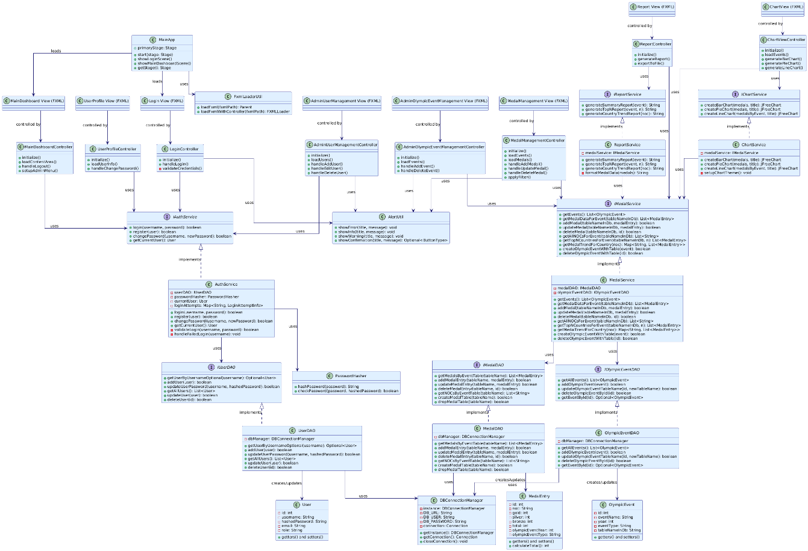

Figure 2. . General model

#### **2.1.2. Functional requirements**

1. **User management and authentication**
   * Login/Logout:
     + The system must provide a login interface for the user to enter a username and password.
     + Authenticate user information with data in MySQL's Users table.
     + Passwords must be stored as hashes (SHA-256) in the database.
     + Error message for incorrect login and handle account lock if necessary.
     + Store the current user information (session) after successfully logging in and redirecting to the Dashboard.
     + Allow users to log out and delete session information.
   * User Profile Management:
     + Displays the basic information (name, email, role) of the logged-in user.
     + Allow users to change their passwords themselves.
   * User Account Management (Admin Only):
     + Admins have permission to view a list of all users.
     + Admins have permissions to add, edit (information, roles), and delete user accounts.
2. **Olympic Medal Data Management**
   * Medal Data Display:
     + Displays a list of medals from a specific Olympiad, selected from the ComboBox.
     + The data is displayed as a table (JavaFX TableView) with the following columns: NOC, HCV Number, HCB Number, Bronze Number, Total Number.
     + Allows sorting of data by columns.
     + Allows filtering of data (according to NOC).
   * Add a new medal record:
     + Provide information entry form: Olympic period, NOC, number of gold medals, bronze medals, bronze medals.
     + Check the validity of the input data.
     + Save the new record to the corresponding DB table.
   * Update the medal record:
     + Allows selecting a record from the table and editing the information.
     + Save your changes to the database.
   * Delete a medal record:
     + Allows selecting a record and deleting it from the database (with confirmation before deletion).
3. **Dashboards and data visualization**
   * Displaying a Dynamic Statistical Chart (using JFreeChart):
     + Bar Chart:
       - The top N countries with the most medals (in total, or by Gold/Silver/Bronze) in a particular Olympics.
       - The number of medals (Gold, Silver, Bronze) of a particular country through different Olympics.
     + Pie Chart:
       - The Gold/Silver/Bronze ratio of a particular country in an Olympics.
     + Line Chart:
       - The trend of a country's total number of medals (or gold medals) through the Olympics.
4. **Other functions and project structure**
   * "Derivable Data":
     + Calculate and display the country with the most gold medals in one period.
     + Calculate and display the total number of medals awarded in a period.
     + Display the overall ranking (based on GOLD MEDAL, HCB, BRONZE).
   * (Admin Only) Olympic Event Management:
     + Admins can add, edit, delete information about the Olympics (name, year, type, name of the corresponding data table).
     + When adding a new Olympics, the system automatically generates the corresponding medal data table.
     + When the Olympics are deleted, the relevant medal data table is also deleted (after confirmation).

#### **2.1.2. Non-functional requests**

1. Security:
   * User passwords must be hashed and stored securely.
   * Clear separation of access between Admin and STAFF.
2. Usability:
   * The user interface should be intuitive, user-friendly, and easy to navigate.
   * Functions should be clear, error/success messages specific to the user.
   * The system's response time must be acceptable.
3. Reliability & Robustness:
   * The app must be stable, not crashing or crashing suddenly.
   * Efficient Exception Handling, friendly error messages, and no application stopping.
   * Ensure data integrity when performing CRUD operations.
4. Maintainability & Extensibility:
   * The source code must be clearly organized, adhering to Java's OOP guidelines and coding conventions.
   * There are comments explaining complex codes.
   * Modularized design for easy modification, upgrade, and addition of new features.
5. Performance:
   * Database queries must be optimized to ensure fast data loading speeds.
   * The display of charts and big data does not slow down the application significantly.

### **2.2. System Design Analysis and User Interface**

#### **2.2.1. System Architecture**

The "Olympic Games Medal Analyzer" application is built on a layered architecture, a close variation of the 3-Tier Architecture or can be viewed as a form of Model-View-Controller (MVC) model adapted to the JavaFX desktop application. The main classes in architecture include:

* **Presentation Layer:**
  + **User Interface (UI):** Built using JavaFX and FXML. FXML files (LoginView.fxml, MainDashboardView.fxml, MedalManagementView.fxml,.. etc.) defines the static structure of the interface. SceneBuilder is used to support the visual design of these FXML files.
  + **Controller (com.duyphuc.olympics.controller):** Each FXML file will have a corresponding Controller class (LoginController.java, MainDashboardController.java,.. These controllers are responsible for handling events from the user (button presses, data input), interacting with the Service class to perform business logic, and updating the user interface as needed. Annotations @FXML used to link components in FXML to Java code in the Controller.
  + **CSS (com.duyphuc.olympics.css):** CSS files (login.css, dashboard_styles.css,.. etc.) are used to customize the interface, ensuring good aesthetics and user experience.
* **Business Logic Layer:**
  + **Service (com.duyphuc.olympics.service):** Contains the entire core business logic of the application. Service classes (AuthService.java, MedalService.java, ChartService.java, ReportService.java,.. etc.) acting as an intermediary between the Controller and the DAO. They take requests from the Controller, process the data, perform calculations, and then call the DAO's methods to interact with the database. For example, AuthService handles user authentication logic, MedalService handles logic related to medal data and prepares data for charts.
* **Data Access Layer:**
  + **DAO (Data Access Object) (com.duyphuc.olympics.dao):** DAO classes (UserDAO.java, MedalDAO.java, OlympicEventDAO.java,.. etc.) responsible for abstracting MySQL database access. Each DAO provides CRUD (Create, Read, Update, Delete) methods for a specific data entity (User, MedalEntry, OlympicEvent). These DAOs execute SQL statements to interact with the database.
  + **Model (com.duyphuc.olympics.model):** Contains POJO (Plain Old Java Objects) entity classes such as User.java, MedalEntry.java, OlympicEvent.java. These classes define the data structure for objects that are used throughout the application, from fetching data from the database, processing it at the Service layer, to displaying it on the interface.
  + **Database Connection Manager (com.duyphuc.olympics.db.DBConnectionManager):** This class manages the creation and closure of connections to MySQL databases. It is implemented in the Singleton pattern to ensure that there is only one instance that manages the connection in the entire application, providing the getConnection() method so that DAOs can get the connection and closeConnection() to close the connection when the application exits.
* **Supported Components:**
  + **Widgets (com.duyphuc.olympics.util):** Contains shared widget classes such as PasswordHasher.java (hash and check passwords), FxmlLoaderUtil.java (download FXML), AlertUtil.java (display notification dialog).
  + **Exception Handling (com.duyphuc.olympics.exception):** Defines custom Exception classes to handle errors in a more specific and explicit way in the application

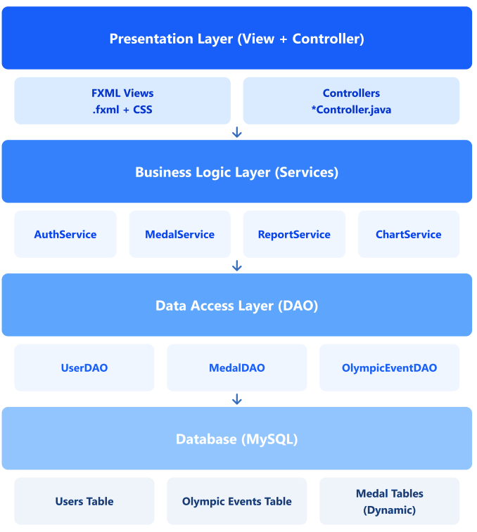

Figure 2. . Layering model

#### **2.2.2. UI Design Analysis**

The user interface (UI) of the "Olympic Games Medal Analyzer" is designed using JavaFX, with the support of FXML to define the structure and SceneBuilder to visualize the design process. The goal is to create an intuitive, easy-to-use, and professional interface that is suitable for the purpose of analyzing and managing Olympic data.

**Login Screen:**

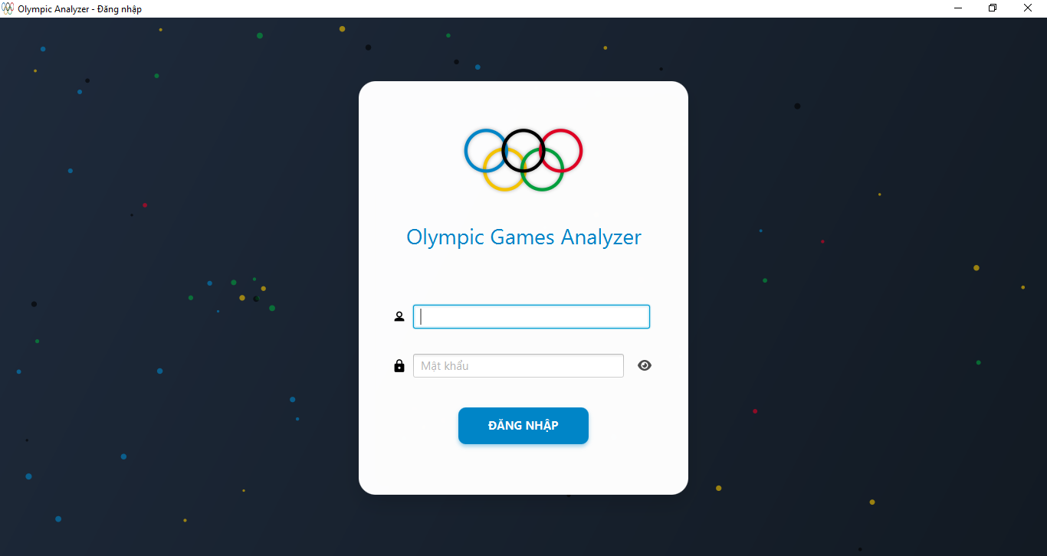

Figure 2. . Login screen

**Main Control Panel:**

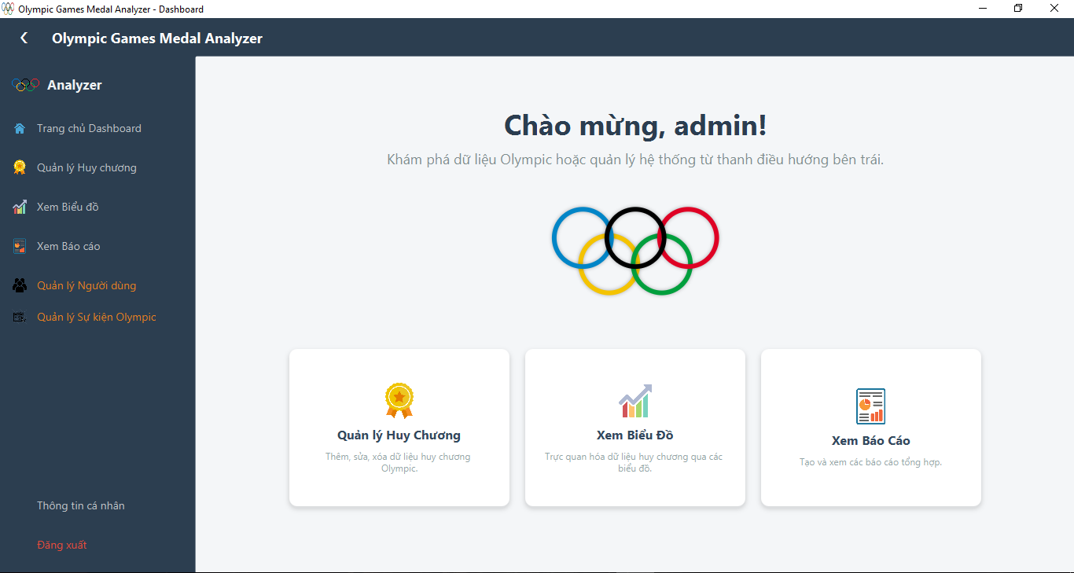

Figure 2. . Main Control Panel

**Medal Data Management Screen:**

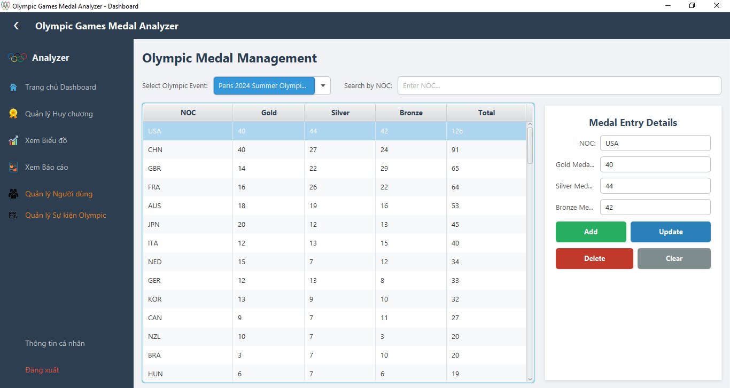

Figure 2. . Medal management screen

**User Management Screen (Admin):**

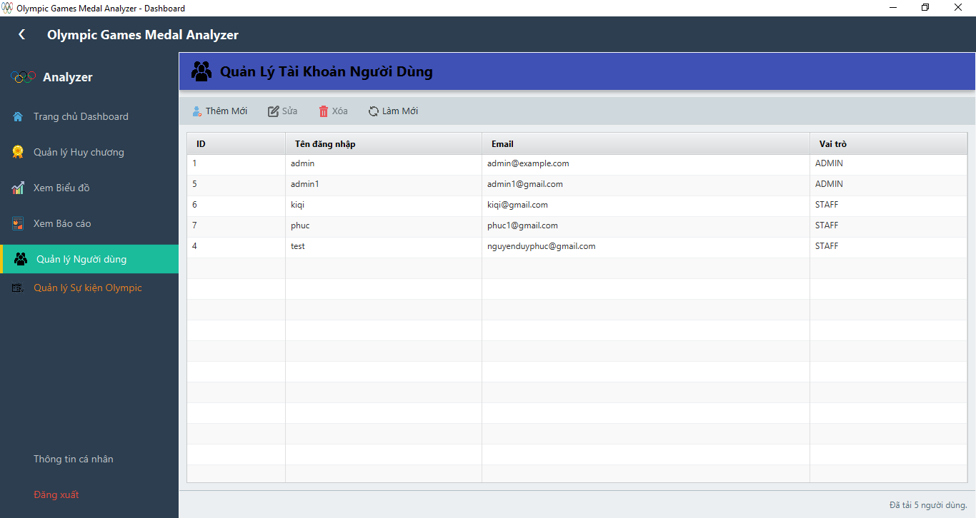

Figure 2. . User management screen

**Olympic Event Management Screen (Admin):**

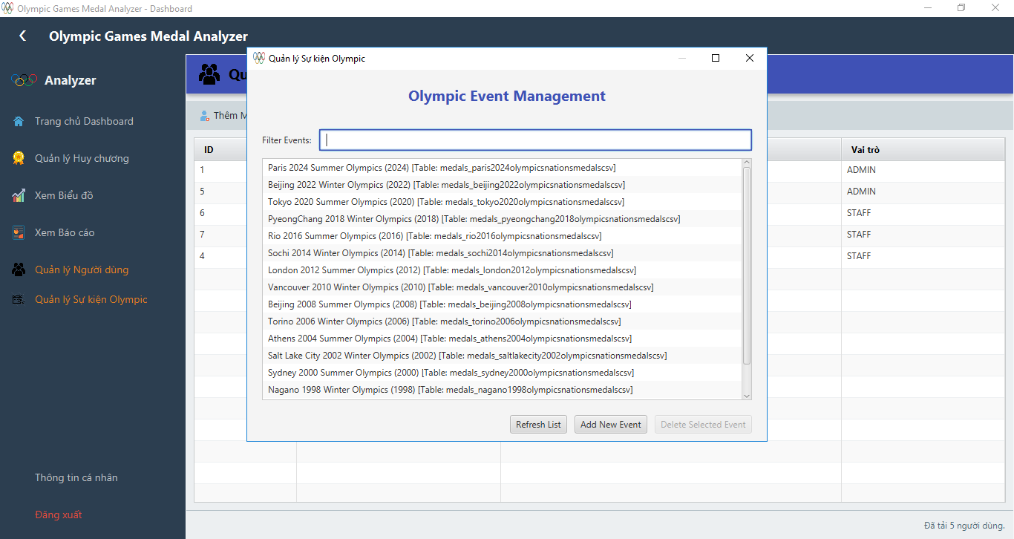

Figure 2. . Event Management Screens

**Chart View Screen:**

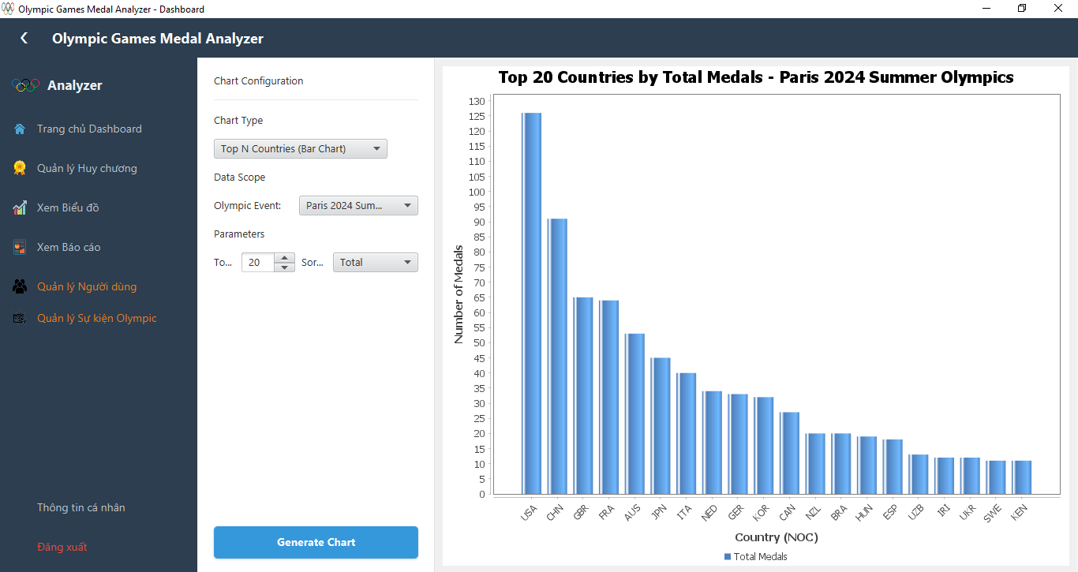

Figure 2. . Chart view screen

**Report View Screen:**

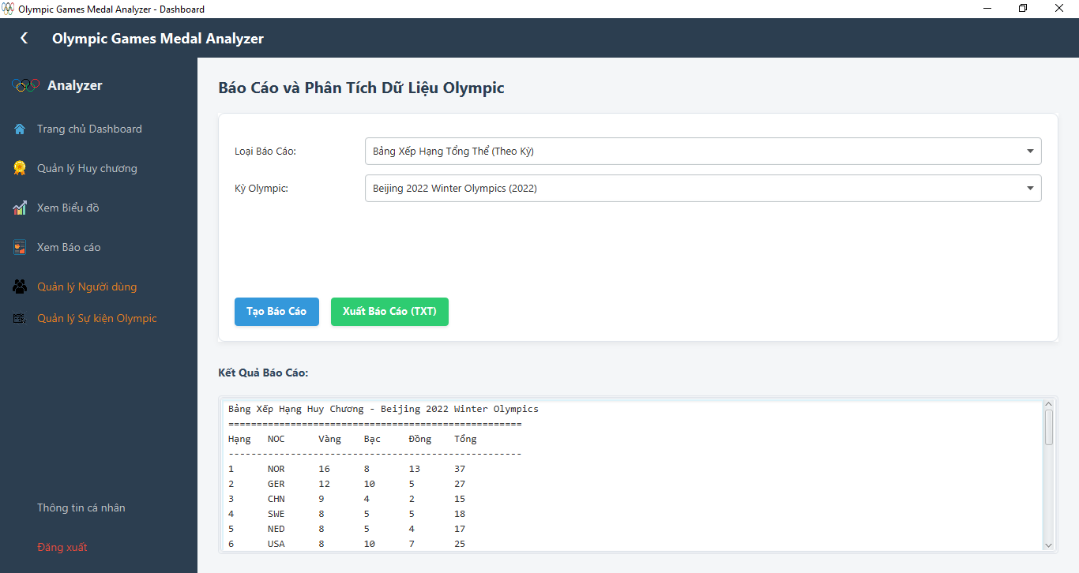

Figure 2. . Report view screen

**User Profile Screen:**

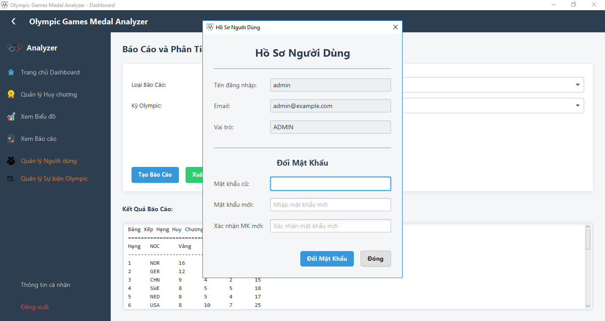

Figure 2. . User Profile Screen

### **2.3. System operation diagram and interface**

* + 1. ***Use Case Diagram***
* Actors:
  + Admin: The user has full control over the system.
  + Staff/Analyst: Users have access to view data, reports, charts, and may have limited data update permissions (depending on the detailed configuration). In the current design, this role is primarily focused on viewing and analyzing.
* Key Use Cases:
  + For all users (Legacy Admin & Staff/Analyst):
  + System Login: Authenticate credentials.
    - Log out of the system: End of the session.
    - View your profile: View your account information.
    - Change Password: Allow users to change their passwords themselves.
    - View medal data: Lookup, filter, and sort medal data.
    - View statistical charts: Visualize medal data through charts.
    - View reports: Create and view aggregated reports.
  + For Admins only:
    - User account management: Add, edit, delete user accounts, assign roles.
    - Olympic medal data management: Add, edit, delete medal data for the Olympic Games.
    - Olympic Event Management: Add, edit, delete information about Olympic events (year, type, name of related data tables).
    - Export Report: Store the report to a file.

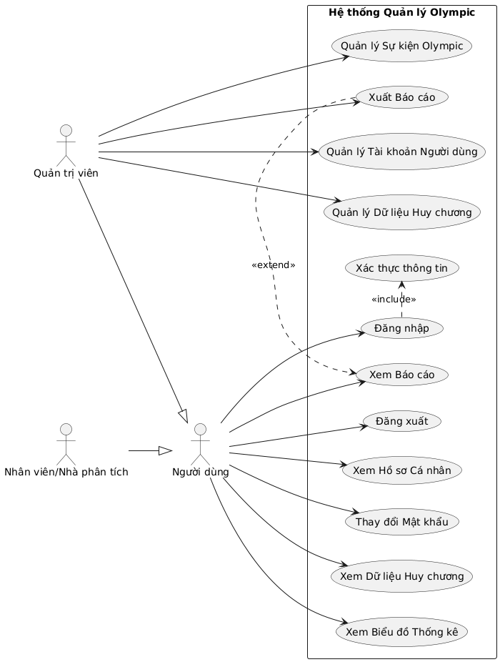

Figure 2. . Use Case diagram illustration

* + 1. ***Login Flow/ Home Page***

This flow describes the process by which a user logs in to the system and the home page interface after a successful login.

1. **Launch the app:**
   * MainApp.java enforced.
   * The LoginView.fxml interface is loaded and displayed first, controlled by LoginController.java.
   * The login interface includes dynamic effects (Olympic Rings, Particle System) to enhance the aesthetics.
2. **The user logs in:**
   * The user enters the Username and Password in the MFXTextField and MFXPasswordField.
   * Press the "LOGIN" button (MFXButton).
3. **Login Handling (LoginController):**
   * Button press events are processed.
   * Gọi AuthService.login(username, password).
   * The AuthService interacts with the UserDAO to query the Users table in the MySQL database, checking the hashed credentials and passwords (SHA-256).
   * Handling of cases:
     + **Login Successful:**
       - User information (including roles) is stored in the AuthService (work session).
       - LoginView closes.
       - MainApp.java load and display MainDashboardView.fxml, controlled by MainDashboardController.java.
       - Display a welcome message on the Dashboard.
     + **Login failure (wrong information):**
       - Displaying an error message on the LoginView (for example, "Incorrect username or password.").
       - Handle the logic of locking the account if the wrong login exceeds the specified number of times.
     + **Locked account:**
       - Show locked account and time remaining notifications
       - Disable the login button during the lockout period.
4. **Giao diện Trang chủ/Dashboard (MainDashboardView.fxml):**
   * Display a sidebar with functions corresponding to the user role.
   * The main content area initially displays welcome information and "access cards" to key functions such as Medal Management, Chart View, Report View.
   * The "Toggle Sidebar" button allows the navigation bar to collapse/expand.
   * Function buttons such as "Personal Information", "Log Out".
   * If the user is an Admin, management items such as "User Management", "Olympic Event Management" will be displayed on the sidebar.

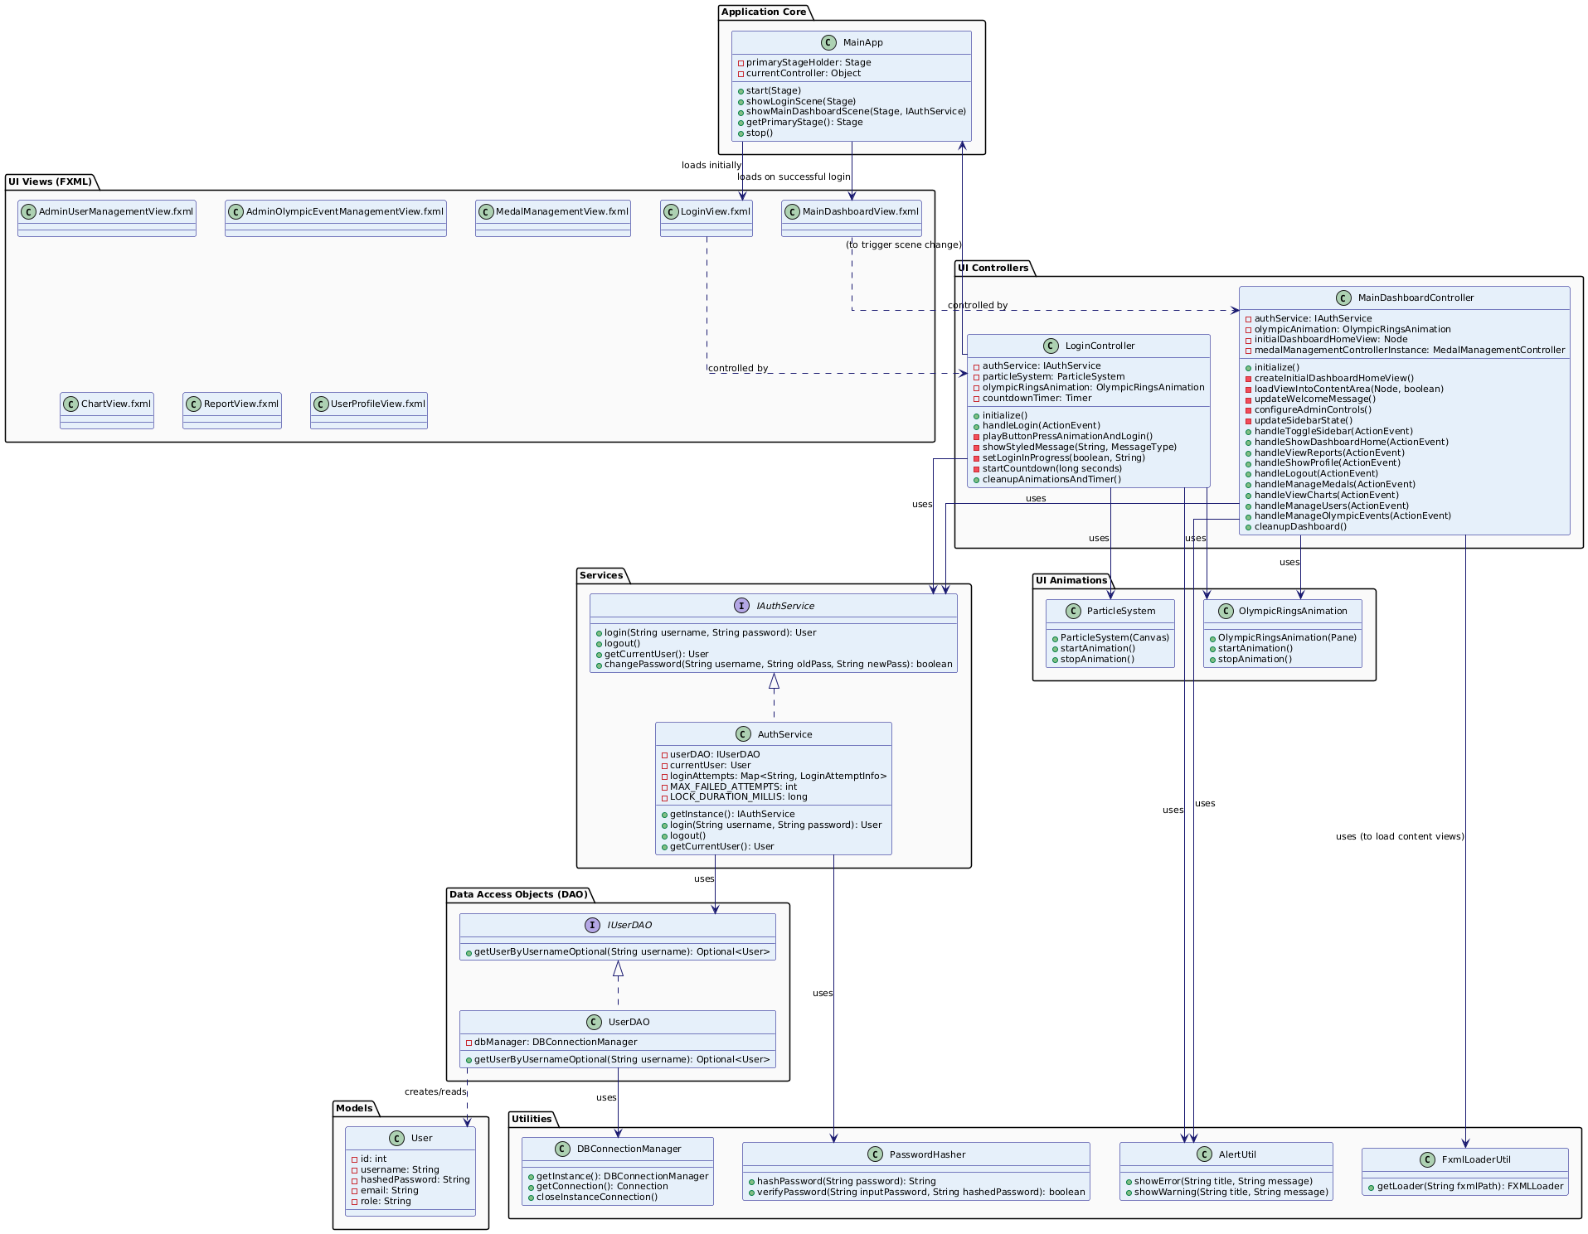

Figure 2. . Login/Home Flow

* + 1. ***Key Data Management (Olympic Medal)***

This stream describes how Admins manage medal data.

1. **Access Functions:**
   * From the MainDashboardView, the Admin presses the "Manage Medals" button.
   * MainDashboardController loads MedalManagementView.fxml into the main content area, controlled by MedalManagementController.java.
2. **Display and Engagement:**
   * MedalManagementController initiated:
     + Download the list of Olympics (from OlympicEventDAO via MedalService) to ComboBox (olympicEventComboBox).
   * When an Admin selects an Olympics from ComboBox:
     + The MedalService is called to retrieve the medal data corresponding to the selected period (based on the OlympicEvent table_name_in_db) from the corresponding database table (e.g. medals_athens2004olympicsnationsmedalscsv).
     + The data is displayed on the TableView (medalTableView) with the columns: NOC, Gold, Silver, Bronze, Total.
     + The formPane is activated.
   * **Filter Data (Extra Feature):** Admins can enter NOCs into the searchTextField to filter the TableView.
   * **Add New (Create):**
     + Admin enters NOC, Gold, Silver, Bronze information in the TextFields in the formPane.
     + Press the "Add" button.
     + The MedalManagementController calls MedalService.addMedal() to save the new record to the database table of the selected Olympiad.
     + The TableView is updated.
   * **Update:**
     + Admin selects a line in the TableView, the information will be populated in the formPane.
     + Admin edit the information.
     + Press the "Update" button.
     + The MedalManagementController calls MedalService.updateMedal() to update the record.
     + The TableView is updated.
   * **Xóa (Delete):**
     + Admin selects a row in the TableView.
     + Press the "Delete" button.
     + The confirmation dialog box is displayed.
     + If confirmed, the MedalManagementController calls MedalService.deleteMedal() to delete the record.
     + The TableView is updated.
   * **"Clear" button:** Whites the fields in the formPane and unchecks them on the TableView.

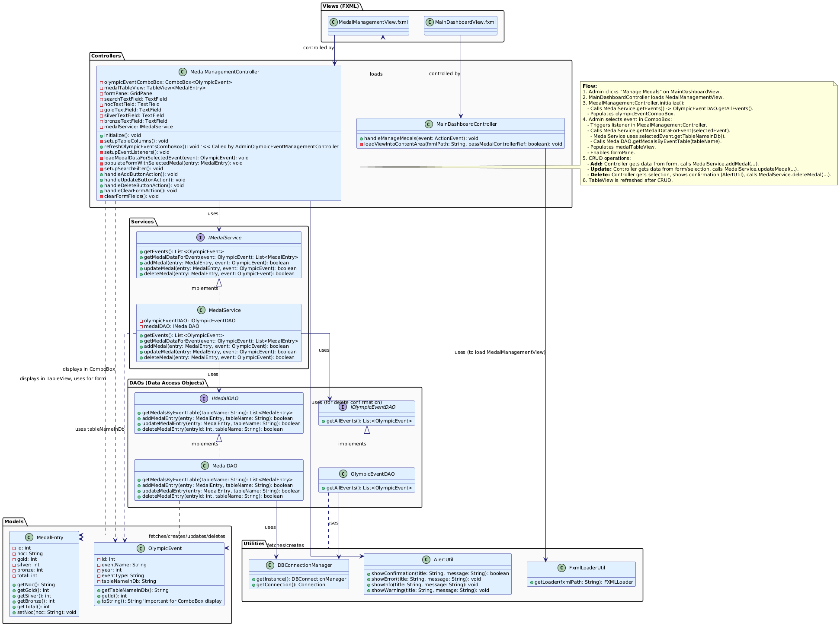

Figure 2. . Medal management flow

* + 1. ***User Management***
* **Interface:**
  + TableView<User> (fx:id="usersTableView"): Displays a list of users with the following columns: ID, Username, Email, Role.
  + Buttons in the ToolBar: "Add New" (fx:id="btnAddUser"), "Edit" (fx:id="btnEditUser"), "Delete" (fx:id="btnDeleteUser"), "Refresh" (fx:id="btnRefresh").
  + **Add/Edit User dialog (UserFormDialog.fxml - displayed as DialogPane):**
    - TextField (fx:id="txtUsernameDialog"): The login name.
    - TextField (fx:id="txtEmailDialog"): Email.
    - PasswordField (fx:id="pfPasswordDialog"): Password (only required when adding new or when wanting to change).
    - PasswordField (fx:id="pfConfirmPasswordDialog"): Confirm the password.
    - ComboBox<String> (fx:id="cmbRoleDialog"): Select the role (ADMIN, STAFF).
    - "Save" and "Cancel" buttons.
* **Activity Flow (AdminUserManagementController):**
  + **Access:** Only Admin can access this screen from the MainDashboardView.
  + **Initialize:** loadUsers() is called, fetches a list of all users from the UserDAO (via AuthService or a separate UserService) and displays it on the usersTableView.
  + **Add a user:** Admin click "Add New".
    - showUserFormDialog(null) is called to display the add user dialog.
    - Admin enter information, select role, click "Save".
    - The controller checks the validity (email, password, username does not match).
    - Call AuthService.registerUser() (or the equivalent in UserService) to hash the password and save it to the database via the UserDAO.
    - If successful, loadUsers() is called back to refresh the table.
  + **Edit User:** Admin select a user from the usersTableView, press "Edit".
    - showUserFormDialog(selectedUser) is called, the dialog displays the current user information (the username is usually not edited).
    - Admin edit Email, Role, (optional) Password.
    - Tap "Save". Controller checks, calls the update method in UserService/AuthService.
    - If successful, loadUsers() is called again.
  + **Delete a user:** Admin select a user, tap "Delete".
    - The confirmation dialog box is displayed. (Note: admins are not allowed to delete their accounts themselves).
    - If confirmed, call the delete method in UserService/AuthService.
    - If successful, loadUsers() is called again.

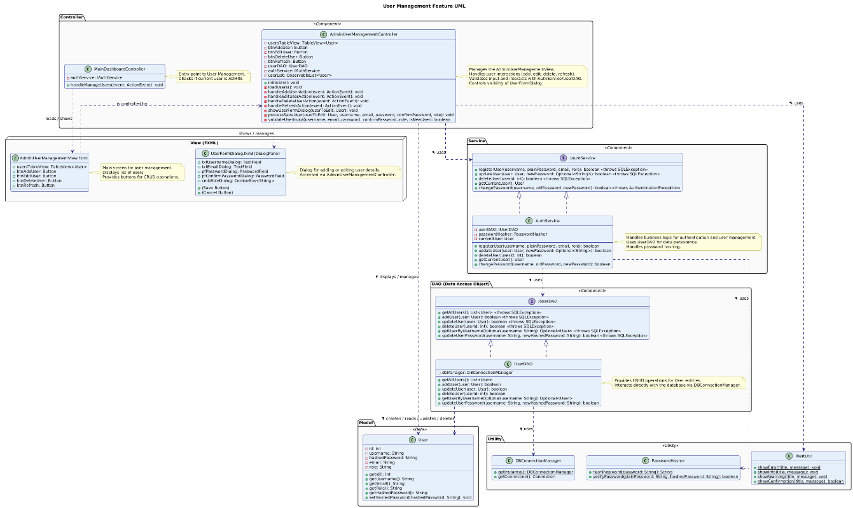

Figure 2. . User management flow

* + 1. ***Statistics and charts***
* **Interface:**
  + Control Panel (VBox fx:id="controlsPanel") on the left:
    - ComboBox<String> (fx:id="chartTypeComboBox"): Select the chart type (Top N Column Chart, Medal Distribution Pie Chart, Trend Line Chart).
    - ComboBox<OlympicEvent> (fx:id="olympicEventComboBox"): Select the Olympic Period (show/hide depending on the chart type).
    - ComboBox<String> (fx:id="countryComboBox"): Select country (NOC) (show/hide depending on chart type, may allow import).
    - Spinner<Integer> (fx:id="topNSpinner"): Select the number of Top N (show/hide depending on the chart type).
    - ComboBox<String> (fx:id="sortByComboBox"): Select the sort criteria (Total, Gold, Silver, Bronze) for the Top N (show/hide depending on the chart type).
    - ComboBox<String> (fx:id="medalTypeComboBox"): Select the medal type for the line chart (Sum, Gold, Silver, Bronze) (show/hide depending on the chart type).
    - Button (fx:id="generateChartButton"): "Generate Chart".
  + The chart display area (StackPane fx:id="chartContainerPane") on the right: Contains a SwingNode (fx:id="swingNodeChart") to embed the ChartPanel from JFreeChart. A ProgressIndicator is added to this StackPane via code to report the load.
* **Activity Flow (ChartViewController):**
  + **Initialize:** Load the list of Olympics into the olympicEventComboBox. Set the default values for the ComboBox and Spinner.
  + **Select Chart Type:** When the user changes the selection in the chartTypeComboBox, updateVisibleControls() is called to show/hide the appropriate parameter controls. validateInputsAndToggleButtonState() is called to check and enable/disable the "Create Chart" button.
  + **Parameter Change:** When the user changes other parameters (Olympics, Country, Top N,...), validateInputsAndToggleButtonState() is called.
  + **Create Chart:** The user presses the "Create Chart" button.
    - handleGenerateChart() is called.
    - loadingIndicator display. The "Create Chart" button is disabled.
    - The Controller collects the selected parameters.
    - A Task<ChartPanel> is created and runs on a background thread to:
      * Call the corresponding methods in the MedalService to retrieve and process the data (e.g., getTopNCountriesForEvent, getMedalDataForCountryInEvent, getMedalTrendForCountry).
      * Call methods in the ChartService (for example, createTopNCountriesBarChart, createMedalDistributionPieChart, createCountryTrendLineChart) to create a JFreeChart ChartPanel object.
    - **Khi Task thành công (setOnSucceeded):**
      * The ChartPanel is taken from the Task.
      * updateChartDisplay(resultPanel) is called to place the ChartPanel on the swingNodeChart.
      * loadingIndicator hidden. The "Create Chart" button is reactivated.
    - **When Task fails (setOnFailed):** Displays an error message. The "Create Chart" button reactivates.

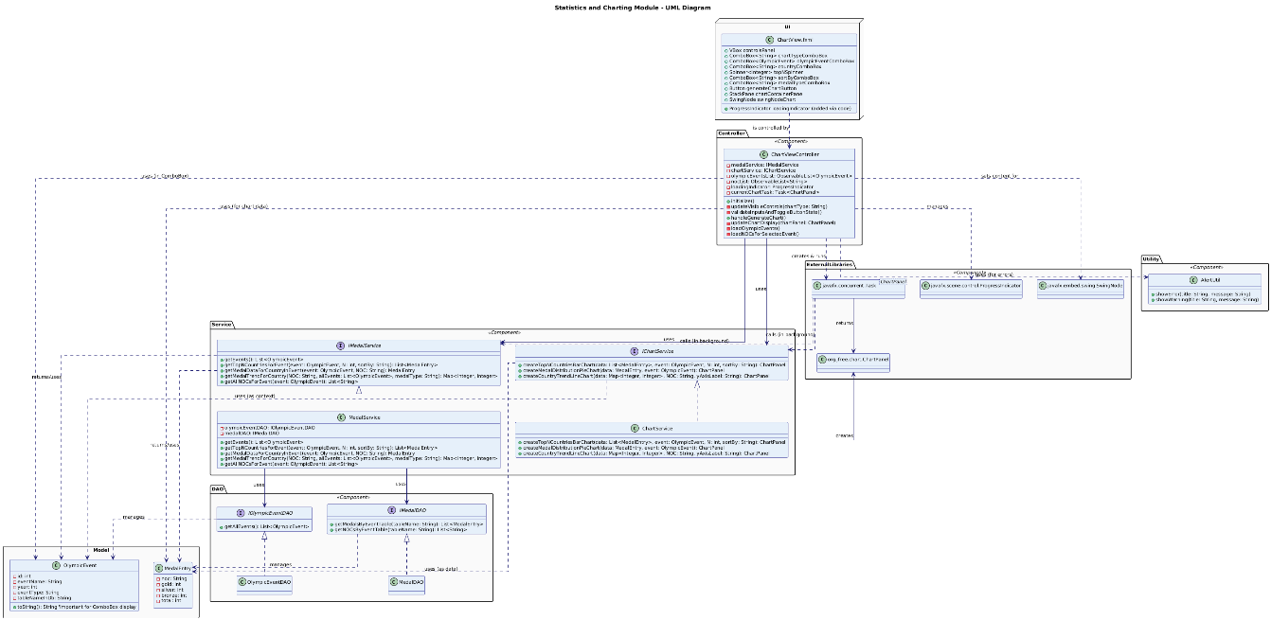

Figure 2. . Statistical and chart flows

### **2.4. MySQL Database Structure**

#### **2.4.1. ERD Model**

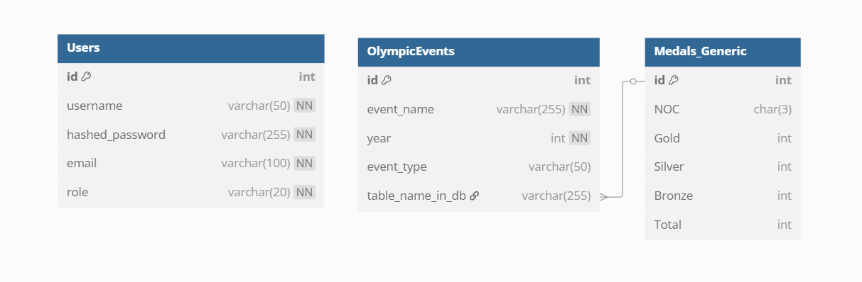

Figure 2. . ERD Model

#### **2.4.2. Description of the data table**

1. **Users Table**
   * **Board Name:** Users
   * **Purpose:** Store user account information for authentication and decentralization.
   * **Columns:**
     + id: INT, PK (Master Key), AI (Auto-Boost) – Unique identifier for each user.
     + username: VARCHAR(50), NOT NULL, UNIQUE - The user's username.
     + hashed_password: VARCHAR(255), NOT NULL – The user's hashed password (using SHA-256).
     + email: VARCHAR(100), NOT NULL, UNIQUE - The user's email address.
     + role: VARCHAR(20), NOT NULL - User role (e.g. 'ADMIN', 'STAFF').
2. **Table olympic_events**
   * **Table Name:** olympic_events
   * **Purpose:** To store information about the Olympic Games, including name, year, type, and most importantly, the name of the database table containing detailed medal data for that period.
   * **Columns:**
     + id: INT, PK (Master Key), AI (Auto Asce) - Unique identifier for each Olympics.
     + event_name: VARCHAR(255), NOT NULL - Full name of the Olympics (e.g., "Athens 2004 Summer Olympics").
     + year: INT, NOT NULL - The year the Olympics took place.
     + event_type: VARCHAR(50) - Olympic type (e.g. "Summer", "Winter").
     + table_name_in_db: VARCHAR(255), NULL, UNIQUE - The name of the table in the database containing the medal data for the corresponding Olympiad. This value is used to dynamically query a specific medal table.
3. **Olympic medal tables (e.g., medals_athens2004olympicsnationsmedalscsv)**
   * **Table name (generic):** medals_[tên_thành_phố][year]olympicsnationsmedalscsv (e.g. medals_beijing2008olympicsnationsmedalscsv)
   * **Purpose:** To store a detailed medal table (by country) for a specific Olympics. Each of these tables corresponds to an event in the olympic_events table.
   * **Columns:**
     + id: INT, PK (Primary Key), AI (Auto-Boost) - The unique identifier for each medal record in this table (added from script 04_insert_medal_data_with_id_column.sql).
     + NOC: CHAR(3), DEFAULT NULL (In the Java createMedalTable file there is NOT NULL, so it will follow this design) - National Olympic Committee code (e.g. "USA", "CHN").
     + Gold: INT, DEFAULT NULL (In the Java createMedalTable file there is DEFAULT 0, so it will follow this design) - The number of gold medals.
     + Silver: INT, DEFAULT NULL (In the Java createMedalTable file, there is a DEFAULT 0, so it will follow this design) - The number of silver medals.
     + Bronze: INT, DEFAULT NULL (In the Java createMedalTable file there is DEFAULT 0, so it will follow this design) - Bronze medal number.
     + Total: INT, DEFAULT NULL (In the Java createMedalTable file there is DEFAULT 0, so it will follow this design) - Total number of medals (usually calculated automatically = Gold + Silver + Bronze).

#### **2.4.3. Binding and Relationship**

* **Constraints:**
  + **Primary Keys:**
    - Users table: id column.
    - Table olympic_events: id column.
    - Mỗi bảng medals_[city][year]olympicsnationsmedalscsv: cột id.
  + **Foreign Keys:**
    - There are no well-defined foreign keys at the database level between olympic_events and medals_ tables... due to the dynamic nature of the table name. This link is managed at the application layer through the table_name_in_db column of the olympic_events table.
    - There are no foreign keys directly from medal tables or events to the Users table in this core data range.
  + **Ràng buộc UNIQUE:**
    - Users table: username, email.
    - Table olympic_events: table_name_in_db (make sure each medal data table name is unique).
    - In each table medals_[city][year]olympicsnationsmedalscsv: NOC column (according to the design logic in MedalDAO.createMedalTable, each country has only one medal record in one Olympics).
  + **NOT NULL Binding:**
    - Bảng Users: username, hashed_password, email, role.
    - Table olympic_events: event_name, year.
    - In each table medals_[city][year]olympicsnationsmedalscsv: NOC column (according to the design logic in MedalDAO.createMedalTable). The medal columns (Gold, Silver, Bronze, Total) have a default value of 0.
* **Quan hệ (Relationships):**
  + **Between olympic_events and the medals_[city][year]olympicsnationsmedalscsv tables:**
    - Relationship Type: 1-1 (Logic).
    - Description: Each record in the olympic_events table (representing an Olympics) will only link to a specific medal data table (e.g., medals_athens2004olympicsnationsmedalscsv). This link is made through the value of the table_name_in_db column in the olympic_events table, which stores the name of the corresponding medal table. The app will use this name to dynamically query the required medal table.
  + **Users Table:**
    - There is no direct foreign lock binding relationship with the Olympic data tables in this design. The Users panel plays an independent role in managing users and access. The decentralization logic will be handled at the application layer based on the role column.

## **Chapter 3: System Mechanism of Operation**

### **Installing Layers and Software Packages**

Projects are organized into logical packages, each of which plays a specific role in the system. This structure follows object-oriented design principles, which helps to manage source code efficiently and enhance reusability.

The main packages in src/main/java/com/duyphuc/olympics/ include:

* main: Contains the MainApp.java class that launches the application.
* controller: Contains the logic control layers for each FXML interface.
* model: Defines the data entity classes (POJOs).
* knives: Classes of Data Access Objects that interact with the database.
* service: Contains the business logic of the application.
* db: Manages the connection to the MySQL database.
* util: Shared utility classes.
* exception: Custom exception classes.
* animation: Layers that handle graphic effects.

In addition, the src/main/resources/com/duyphuc/olympics/ package contains resources such as:

* fxml: The FXML file that defines the interface.
* css: CSS files to customize the look.
* images: Images used in the app
  + 1. ***Model Class***

The com.duyphuc.olympics.model package contains pure Java classes (POJOs - Plain Old Java Objects) that represent the core data entities of the system. These layers serve as data patterns, which are used to convey information between the different layers of the application.

* User.java:
  + Purpose: Represents a user in the system.
  + Thuộc tính chính: id (int), username (String), hashedPassword (String), email (String), role (String, ví dụ: "ADMIN", "STAFF").
  + Activity: Each User object stores the information of an account. Properties are designed to be private and accessed through public getters and setters, ensuring encapsulability.
* MedalEntry.java:
  + Purpose: To represent a record of a country's medals at a particular Olympics.
  + Thuộc tính chính: id (int, nếu có), noc (String - National Olympic Committee code), gold (int), silver (int), bronze (int), total (int), olympicEventYear (int), olympicEventType (String).
  + Activity: This layer is used to store and manipulate medal data. The total number of medals can be automatically calculated in gold, silver, and bronze setters.
* OlympicEvent.java:
  + Purpose: To represent an Olympic Games.
  + Main attributes: id (int), eventName (String, e.g. "Athens 2004 Summer Olympics"), year (int), eventType (String, e.g. "Summer", "Winter"), tableNameInDb (String - the name of the database table containing the medal data for that period).
  + Activity: This layer helps manage information about the Olympics and links to the corresponding medal data table in the database.
    1. ***Lớp DAO (Data Access Object)***

The com.duyphuc.olympics.dao package is responsible for abstracting database access. Each DAO class provides methods for performing CRUD (Create, Read, Update, Delete) operations on a specific data entity, separating the data access logic from the business logic.

* **UserDAO.java (IUserDAO.java deployment):**
  + **Purpose**: Perform database operations related to the User entity.
  + **Main Methods**:
    - getUserByUsernameOptional(String username): Queries the user by username.
    - addUser(User user): Adds a new user to the database.
    - updateUserPassword(String username, String newHashedPassword): Updates the user password.
    - getAllUsers(): Gets a list of all users.
    - updateUser(User user): Updates user information.
    - deleteUser(int userId): Deletes the user.
  + **Operation**: Use DBConnectionManager to get connections and execute SQL statements (usually PreparedStatement to avoid SQL Injection) that interact with the Users table.
* **MedalDAO.java (triển khai IMedalDAO.java)**:
  + **Purpose**: Perform database operations related to medal tables (e.g., medals_athens2004olympicsnationsmedalscsv).
  + **Main Methods**:
    - getMedalsByEventTable(String tableName): Retrieves all medal records from a specific event table.
    - addMedalEntry(MedalEntry entry, String tableName): Adds a medal record.
    - updateMedalEntry(MedalEntry entry, String tableName): Updates a medal record.
    - deleteMedalEntry(int entryId, String tableName): Deletes a medal record.
    - getNOCsByEventTable(String tableName): Retrieves a list of unique NOC IDs from an event table.
    - createMedalTable(String tableName, Connection conn): Creates a new medal table.
    - dropMedalTable(String tableName, Connection conn): Deletes a medal table.
  + **Operation**: Similar to UserDAO, this class uses DBConnectionManager and PreparedStatement to manipulate dynamic medal tables in the database.
* **OlympicEventDAO.java (IOlympicEventDAO.java deployment):**
  + **Purpose**: Perform database operations related to olympic_events tables.
  + **Main Methods**:
    - getAllEvents(): Retrieves a list of all the Olympiads.
    - addOlympicEvent(OlympicEvent event, Connection conn): Adds a new Olympiad (usually does not include the original tableNameInDb).
    - updateOlympicEventTableName(int eventId, String tableName, Connection conn): Updates the name of the database table for an Olympic period.
    - deleteOlympicEventById(int eventId, Connection conn): Xóa một kỳ Olympic.
  + **Activities**: Manage metadata information about the Olympics, including linking them to specific medal tables.
    1. ***Service Class***

The com.duyphuc.olympics.service package contains the application's business logic. The Service classes act as an intermediary between the Controller and DAO classes, coordinating operations and data processing.

* **AuthService.java (Triển Khai IAuthService.java):**
  + **Purpose**: Handle logic related to authentication and user session management.
  + **Main Methods**:
    - login(String username, String password): Authenticate credentials, check hashed passwords, manage incorrect logins, and lock temporary accounts.
    - logout(): Removes the current user information from the session.
    - getCurrentUser(): Returns the logged-in user information.
    - changePassword(String username, String oldPassword, String newPassword): Xử lý logic đổi mật khẩu.
  + **HoServlet**: Calls UserDAO to query user information and PasswordHasher to verify passwords.
* **MedalService.java (triển khai IMedalService.java)**:
  + **Purpose**: To provide services related to Olympic medal data.
  + **Main Methods**:
    - getEvents(): Retrieves the list of Olympics from the OlympicEventDAO.
    - getMedalDataForEvent(OlympicEvent event): Retrieves medal data for a specific Olympics from the MedalDAO.
    - addMedal(), updateMedal(), deleteMedal(): Handles the CRUD logic for medals, calling the corresponding methods of MedalDAO.
    - getAllNOCsForEvent(OlympicEvent event): Gets a list of NOCs for an event.
    - getTopNCountriesForEvent(OlympicEvent event, int N, String sortBy): Get the top N countries based on the sort criteria.
    - getMedalDataForCountryInEvent(OlympicEvent event, String NOC_Code): Retrieves a country's medal data for a period.
    - getMedalTrendForCountry(...): Takes a country's medal trend over periods.
    - createOlympicEventWithTable(...): Creates a new Olympic event and the corresponding medal table (using a transaction).
    - deleteOlympicEventWithTable(...): Deletes the Olympic event and the associated medal table (using the transaction).
  + **Activities**: Coordinate activities between OlympicEventDAO and MedalDAO, perform necessary calculations, sort, and filter data.
* **ChartService.java (IChartService.java deployment):**
  + **Purpose**: Create ChartPanel objects from the JFreeChart library based on the data provided.
  + **Main Methods**:
    - createTopNCountriesBarChart(...): Creates a country top N column chart.
    - createMedalDistributionPieChart(...): Creates a pie chart of medal distribution.
    - createCountryTrendLineChart(...): Creates a medallion trendline chart.
  + **Operation**: Takes the processed data (usually from the MedalService), configures and creates JFreeChart objects, and then wraps them into the ChartPanel so that it can be embedded in the JavaFX interface via SwingNode.
* **ReportService.java (triển khai IReportService.java)**:
  + **Purpose**: Create text reports based on Olympic data.
  + **Main Methods**:
    - generateOverallRankingReportForEvent(...): Creates a leaderboard report for a period.
    - getCountryWithMostGoldMedalsInEvent(...): Take the country with the most gold medals.
    - getTotalMedalsAwardedInEvent(...): Calculate the total number of medals awarded.
    - getTopNCountriesByTotalMedalsInEvent(...): Get the top N countries by total medals.
    - getCountryPerformanceAcrossEvents(...): Retrieves a country's performance over periods.
    - getOverallLeaderboardAllEvents(...): Creates an overall leaderboard across all periods.
* **Activity**: Use MedalService to retrieve data, then format it into a report text string.
  + 1. ***Service Class***

The com.duyphuc.olympics.controller package contains the control layers (Controllers) for each FXML monitor. These controllers handle events from the UI, interact with Service classes to make requests, and update the interface as needed.

* **LoginController.java**:
  + **Purpose**: Handle the logic for the login screen (LoginView.fxml).
  + **Activity**: Receives login credentials from the user, calls AuthService.login(). If successful, redirect to MainDashboardView. Displays an error message if the login fails. Manage animation effects.
* **MainDashboardController.java**:
  + **Purpose**: Manage the main interface of the application (MainDashboardView.fxml), including the navigation bar (sidebar) and the main content display area.
  + **Activity**: Handles navigation events (e.g. clicking on the "Medal Management" button will load MedalManagementView.fxml into the content area). Manage the status of the sidebar (open/closed). Log out processing.
* **MedalManagementController.java**:
  + **Purpose**: Handle the logic for the medal management screen (MedalManagementView.fxml).
  + **Activity**: Display the ComboBox to select the Olympics. When a period is selected, call MedalService to upload the medal data and display it to the TableView. Handle events to add, edit, delete medal records by calling the corresponding methods of MedalService.
* **UserProfileController.java**:
  + **Purpose**: To display and enable updates to user profile information (UserProfileView.fxml).
  + **Activity**: Displays current user information. Allow the user to change the password by calling AuthService.changePassword().
* **AdminUserManagementController.java**:
  + **Purpose**: (Admin Only) Manage User Accounts (AdminUserManagementView.fxml).
  + **Activity**: Displays a list of users. Allows Admins to add, edit (roles, emails), delete user accounts via UserDAO or AuthService.
* **AdminOlympicEventManagementController.java**:
  + **Purpose**: (Admin Only) Managing the Olympics (AdminOlympicEventManagementView.fxml).
  + **Activities**: Displays a list of Olympics. Allows Admins to add new Olympic flags (with the creation of corresponding medal tables) and delete Olympic flags (with the deletion of medal tables) through MedalService.
* **ReportController.java**:
  + **Purpose**: Generate and display text reports (ReportView.fxml).
  + **Activity**: Allows users to select the type of report and the required parameters (if applicable). Call the ReportService methods to create the report content and display it on the TextArea.
* **ChartViewController.java**:
  + **Purpose**: To display statistical charts (ChartView.fxml).
  + **Activity**: Allows users to select the chart type, Olympic period, country, and other parameters. Call MedalService to get data and ChartService to create a ChartPanel. The ChartPanel is then embedded in the SwingNode for display in the JavaFX interface.
    1. ***Utilities***

The com.duyphuc.olympics.util, db, exception, and animation packages contain utility classes that support various functions in the application.

* **PasswordHasher.java (trong util)**:
  + **Purpose**: Provides methods for hashing passwords (e.g., using SHA-256 from the Apache Commons Codec) and checking passwords.
  + **Activity**: Used by AuthService during registration and login.
* **FxmlLoaderUtil.java (useful trunk):**
  + **Purpose**: Simplify the loading of FXML files and get Controller objects (if needed).
  + **Operation**: Used by MainApp and other Controllers when a new FXML view needs to be loaded.
* **AlertUtil.java (trong util):**
  + **Purpose**: To provide convenient ways to display JavaFX's standard message dialogs (errors, information, warnings, confirmations).
  + **Operation**: Used by Controllers to notify the user of the result of an operation or error.
* **DBConnectionManager.java (db trong):**
  + **Purpose**: Manage connections to MySQL databases.
  + **Operation**: Deploy in a Singleton pattern to ensure that only one instance manages connectivity throughout the application. Provides the getConnection() method for the DAO classes to fetch the connection and closeInstanceConnection() to close the connection when the application exits.
* **Classes in exception (AuthenticationException.java):**
  + **Purpose**: Define custom exceptions to handle specific error situations in your application, making it clearer to catch and handle errors.
  + **Activity**: An AuthenticationException thrown by the AuthService when authentication fails, which can contain information about the account being locked out and the lockout time.
* **Các lớp trong animation (OlympicRingsAnimation.java, ParticleSystem.java)**:
  + **Purpose**: Create graphic effects to enhance the aesthetics and user experience of the app, such as the Olympic circle effect on the login screen or dashboard.
  + **Operation**: Use the JavaFX Animation API's layers to create movements and effects.

### **3.2. User authentication mechanism**

* + 1. ***Login Session Management***

Login session management ensures that the user's sign-in state is maintained throughout the use of the app and is securely canceled when the user logs out or closes the app.

* **Session Initiation (Login):**
  1. The user enters the username and password in the LoginView.fxml interface managed by LoginController.java.
  2. When the user presses the "LOGIN" button, the LoginController calls the login method (username, password) of the AuthService.java.
  3. AuthService uses UserDAO.java (specifically the getUserByUsernameOptional(username)) method to query the MySQL database, searching for users based on their usernames.
  4. If the user exists, AuthService will call PasswordHasher.verifyPassword() to compare the password entered by the user (after being hashed) with the hashed password stored in the database (hashed_password in the Users table).
  5. **Handling failed logins and account lockouts:** AuthService implements a mechanism for counting consecutive false logins for each account through the Map loginAttempts and the LoginAttemptInfo inner layer.
     + If the account is being locked (lockReleaseTimeMillis > System.currentTimeMillis()), an AuthenticationException will be thrown, announcing the remaining time of the lock. The LoginController will display this message and disable the login button.
     + If the login is incorrect but not locked, the number of failed attempts will increase. If the MAX_FAILED_ATTEMPTS is exceeded (e.g., 5 times), the account will be locked for a period of LOCK_DURATION_MILLIS (e.g., 30 seconds).
  6. **Login Successful:** If authentication is successful and the account is not locked, user information (including id, username, email, role) is stored in a currentUser variable (User type) inside the AuthService. This currentUser variable acts as a "session" for the current user. The number of failed logins is reset.
  7. The LoginController will then navigate the user to the main interface (MainDashboardView.fxml) via MainApp.showMainDashboardScene(), passing the AuthService (or User) object so that other controllers can access the current user information.
* **Session Maintenance:**
  1. AuthService objects are either designed in a Singleton pattern (AuthService.getInstance()) or passed between controllers. This allows any part of the app to also be able to access the logged-in user information via authService.getCurrentUser().
  2. The session is maintained as long as the currentUser object in the AuthService is not null.
* **End of session (Logout):**
  1. When the user selects the logout function from the MainDashboardController.java (e.g., via the "Sign Out" button), the logout() method of the AuthService is called.
  2. AuthService.logout() will reset currentUser to null, removing the user's session information.
  3. The app then navigates the user back to the login screen (LoginView.fxml) via MainApp.showLoginScene().
  4. Animations and timers related to the login interface (e.g. olympicRingsAnimation, particleSystem, countdownTimer in the LoginController) are also cleaned up via the cleanupAnimationsAndTimer() method to free up resources.
* **Clean up resources when closing the app:**
  1. The stop() method in MainApp.java ensures that resources such as database connections (DBConnectionManager.closeInstanceConnection()) and current animations/controllers are cleaned up (cleanupCurrentController()) before the application exits completely.
     1. ***Password encryption***

To ensure the security of users' password information, the system does not store passwords in plain text but uses a one-way hashing technique.

1. **Password Storage:**
   * When a user registers (this functionality can be added to the AdminUserManagementController or a separate registration process) or when an admin creates/updates a user password, the plain text password is hashed before being saved to the database.
   * The hashed_password column in the Users table (declared in 00_create_users_table.sql) stores this hash string.
   * Layer PasswordHasher.java (in the com.duyphuc.olympics.util package) is responsible for the hashing of passwords. The hashPassword(String plainPassword) method uses the SHA-256 algorithm (via the Apache Commons Codec library, declared in pom.xml and illustrated in test.java with DigestUtils.sha256Hex()).
2. **Password verification:**
   * During the login process, after the user enters the password, AuthService.login() retrieves the hash string of the saved password from the database for the corresponding user.
   * The AuthService then calls the PasswordHasher.verifyPassword(String plainPassword, String hashedPassword) method. This method will hash the plainPassword password that the user has just entered (using the same SHA-256 algorithm) and compare the results with the hashedPassword string saved in the database.
   * If the two hash strings match, the password is considered valid.
3. **Change your password:**
   * When a user (or admin) performs a password change function (e.g. in UserProfileController.handleChangePassword() or AdminUserManagementController.processSaveUser()), the new password will also be hashed using PasswordHasher.hashPassword() before being updated to the database via UserDAO.updateUserPassword() or UserDAO.updateUser().

**Advantages of password hashing:**

* **Security:** Even if the database is compromised, an attacker cannot obtain the user's root password because the hash is one-way (it is not possible to reverse from the hash string to the root password easily).
* **Standard Compliance:** Using strong hashing algorithms like SHA-256 is a good security practice.

**Note:** Although SHA-256 is a good hashing algorithm, for further added security, modern systems often incorporate "salting" (adding a random string to a password before hashing) to combat rainbow table attacks. Within the framework of this project, the use of basic SHA-256 has met the requirement that "passwords must be stored as hashes".

* + 1. ***Decentralize users***

After a user is successfully authenticated, the system needs to determine what functions and data that user is allowed to access. This is done based on the user's role.

1. **Role Definition:**
   * In the data model (User.java and the Users table in 00_create_users_table.sql), each user has a role attribute/column (e.g., "ADMIN", "STAFF").
   * Topics require at least the "Admin" role with full permissions and possibly the "Staff/Analyst" role with more limited permissions.
2. **Permission check mechanism:**
   * After successful sign-in, user information including roles is saved in the AuthService's currentUser object.
   * At the points where access control is required in the application, the role of currentUser is checked.
   * **Examples in MainDashboardController.java:**
     + Method configureAdminControls(): Check currentUser.getRole(). If it is "ADMIN", admin-specific buttons/sections (e.g. manageUsersButton, manageOlympicEventsButton in adminSection) will be displayed; on the contrary, they will be hidden.
     + Event handling methods such as handleManageUsers() and handleManageOlympicEvents(): Before taking action, they double-check the role of currentUser. If not "ADMIN", an "Access Denied" error message will be displayed via AlertUtil.showError(), and the user is navigated to the dashboard home page.
   * **Examples in AdminUserManagementController.java and AdminOlympicEventManagementController.java:** These controllers manage functions that are only for the Admin. Access to these views is already controlled from the MainDashboardController.
3. **Degree of decentralization:**
   * **Admin:**
     + Have access to all management modules: users, medal data, Olympic events.
     + It is possible to perform a full range of CRUD (Create, Read, Update, Delete) operations on all types of data.
     + View all reports and charts.
   * **Staff/Analyst:**
     + The right to view medal and Olympic event data.
     + Permission to view reports and charts.
     + Restrict user management and event management

### **3.3. Data management mechanism**

The data management mechanism is a central part of the application, ensuring the efficient and accurate storage, retrieval and manipulation of Olympic medal information. The system uses a MySQL database, which is managed through SQLYog, and data operations are performed in Java through JDBC.

* + 1. ***Connect to a database***

The connection to the MySQL database is centrally managed by the DBConnectionManager class in the com.duyphuc.olympics.db package. This class is designed according to the Singleton pattern, which ensures that only a single instance of DBConnectionManager is created throughout the lifecycle of the application. This helps manage connection resources effectively, avoiding waste and potential problems associated with opening too many connections simultaneously.

* **Singleton Implementation:** The DBConnectionManager class has a private constructor to prevent the creation of objects from the outside. A static synchronized getInstance() method is provided to access a single instance of the class. This method checks if the instance has been created; if not, it will create a new one.
* **Connection Information:** The information required to connect to the database such as the database URL (DB_URL), username (DB_USER), and password (DB_PASSWORD) is defined as the private static final String constants inside the DBConnectionManager class. In a production environment, this information is usually stored in a configuration file (properties file) to increase security and flexibility, however, within the framework of this project, they are declared directly for simplicity.
* **Fetching and Closing Connections:** The DBConnectionManager class provides a getConnection() method so that DAO (Data Access Object) classes can obtain java.sql.Connection objects. It also checks the validity of the current connection (e.g., connection == null || connection.isClosed()) and recreates the connection if necessary. (Page 128, DBConnectionManager.java). Closing the connection is done carefully through the closeInstanceConnection() method when the application is terminated or when it is no longer needed, and the close(Connection conn, Statement stmt, ResultSet rs) utility methods to free up resources after each DB operation.
  + 1. ***CRUD***

Create, Read, Update, and Delete data are performed through the DAO layers in the com.duyphuc.olympics.dao package. Each DAO class is responsible for interacting with a table or a group of related tables in the database.

* **UserDAO (IUserDAO.java, UserDAO.java):** Manages operations related to the Users table. These include methods such as getUserByUsernameOptional(String username) to get user information, addUser(User user) to add new users, updateUserPassword(String username, String newHashedPassword) to update passwords, getAllUsers() to get a list of all users, updateUser(User user) to update user information, and deleteUser(int userId) to delete users. The corresponding SQL statements (SELECT, INSERT, UPDATE, DELETE) are executed through PreparedStatement to ensure safety and efficiency.
* **MedalDAO (IMedalDAO.java, MedalDAO.java):** Responsible for operations on medal data sheets (e.g., medals_athens2004olympicsnationsmedalscsv). Provides methods such as getMedalsByEventTable(String tableName) to retrieve the medal list of a specific Olympic Games, addMedalEntry(MedalEntry entry, String tableName) to add a medal record, updateMedalEntry(MedalEntry entry, String tableName) to update, and deleteMedalEntry(int entryId, String tableName) to delete a record. This class also has methods for creating (createMedalTable) and deleting (dropMedalTable) medal tables.
* **OlympicEventDAO (IOlympicEventDAO.java, OlympicEventDAO.java):** Manages information about the Olympics in the olympic_events table. Include getAllEvents() to get a list of all Olympiads, addOlympicEvent(OlympicEvent event, Connection conn) to add a new Olympiad (return the ID of the newly created event), updateOlympicEventTableName(int eventId, String tableName, Connection conn) to update the medal table name corresponding to an Olympiad, and deleteOlympicEventById(int eventId, Connection conn) to delete an Olympics.

All DAO methods use the Connection object provided by the DBConnectionManager and handle the SQLException that can occur during interaction with the database. The use of PreparedStatement helps prevent SQL injection and improves performance when executing repetitive SQL statements.

* + 1. ***Java Collections in Data Management***

The system makes efficient use of data structures from the Java Collections Framework to manage, store, and manipulate in-memory data before displaying or processing it.

* **ArrayList:**
  + ArrayList<OlympicEvent>: Used in OlympicEventDAO and MedalService to store a list of Olympics retrieved from a database. ArrayList is suitable for storing and sequentially accessing a list of events, for example when displayed on a ComboBox for the user to choose from.
  + ArrayList<MedalEntry>: Used in MedalDAO and MedalService to contain a list of medal records for a specific Olympic Games. This data is then displayed to the TableView in the medal management interface.
  + In the ReportService, ArrayList<MedalEntry> is used to store the results of the reports before formatting them into a series for display.
* **List (Interface):**
  + Most DAO and Service methods return Lists (e.g., List<User>, List<OlympicEvent>, List<MedalEntry>) for added flexibility, allowing specific settings to be changed (e.g. from ArrayList to LinkedList) without affecting the classes used.
* **ObservableList:**
  + ObservableList<OlympicEvent> and ObservableList<MedalEntry> are used in Controller classes (e.g., MedalManagementController, AdminOlympicEventManagementController) to associate data with JavaFX interface components such as ListView and TableView. When the data in the ObservableList changes, the UI updates automatically.
* **FilteredList and SortedList:**
  + In the MedalManagementController, the FilteredList<MedalEntry> is used to support the search/filter of medal data based on the NOC that the user enters into the searchTextField.
  + The SortedList<MedalEntry> is wrapped around the FilteredList to allow the data to be sorted in the TableView when the user clicks on the column header.
* **HashMap and TreeMap (Mentioned in the request, applicable):**
  + Although not clearly visible in the Java source code provided, as required by "Module 4: Other Functions & Project Structure" and "Key Objectives", HashMap or TreeMap can be used in ChartService or MedalService to prepare data for charting. For example, HashMap<String, Integer> can store the total number of medals (Integer) by country (String - NOC) to plot column or pie charts. TreeMap can be used if data is needed to be automatically sorted by key (e.g., by year or by country name).
  + In AuthService, Map<String, LoginAttemptInfo> loginAttempts = new HashMap<>(); Used to store information about the number of failed logins and when the account was locked. HashMap is suitable here because it requires quick access to username-based credentials.
* **Set (e.g. HashSet, TreeSet):**
  + Although not directly used in the display code, Sets can be used in business logic to ensure the uniqueness of certain data, such as a list of unique NOCs participating in an Olympics.

### **3.4. Chart display mechanism**

One of the key functions of the "Olympic Games Medal Analyzer" is the ability to visualize medal data through charts. The system uses the JFreeChart library to create dynamic charts, allowing users to explore and analyze information efficiently. This mechanism includes the integration of JFreeChart into the JavaFX interface and the process of creating specific types of charts.

* + 1. ***JFreeChart Integration***

Because JFreeChart is a Swing-based graphics library, while the application's user interface (GUI) is built using JavaFX, integration requires a solution to "embed" Swing content inside a JavaFX application.

* **Using SwingNode**:
  + In ChartViewController.java, a javafx.embed.swing.SwingNode object named swingNodeChart is declared and used. SwingNode is a special layer in JavaFX that allows Swing content to be displayed inside a JavaFX Scene Graph.
  + When a JFreeChart (usually an org.jfree.chart.ChartPanel) is created by the ChartService, it is assigned to the SwingNode via the swingNodeChart.setContent(chartPanel) method. This is done in the updateChartDisplay(final ChartPanel) method of the ChartViewController.java.
* **Asynchronous processing flow**:
  + Creating charts, especially when there is a lot of data, can be a time-consuming task. To avoid freezing the UI, the chart creation process is performed in a background task (javafx.concurrent.Task).
  + In ChartViewController.java, a Task<ChartPanel> is created. The call() method of this Task will call the methods in the ChartService to create the ChartPanel.
  + After the Task completes (setOnSucceeded), the resulting ChartPanel will be displayed to the SwingNode on the JavaFX Application Thread via Platform.runLater() (implicit in setOnSucceeded or explicitly called if necessary).
* **Control Interface (FXML):**
  + The ChartView.fxml file defines a StackPane named chartContainerPane that contains a SwingNode (fx:id="swingNodeChart"). This StackPane is also used to display the ProgressIndicator (loadingIndicator – pages 68, 70) while the chart is being created.
    1. ***Bar Chart***

Column charts are used to compare the number of medals between different countries or categories. A specific example in the app is "Top N Countries (Bar Chart)".

* **Data collection**:
  1. The user selects the chart type "Top N Countries (Bar Chart)" from the chartTypeComboBox in the ChartViewController.
  2. The user selects a specific Olympics from the olympicEventComboBox, the number of countries (N) from topNSpinner, and the sorting criteria (e.g. Total, Gold) from sortByComboBox.
  3. When the "Generate Chart" button is pressed, handleGenerateChart() is called.
  4. Inside the Task, the medalService.getTopNCountriesForEvent(selectedEvent, nValue, sortBy) method is called to retrieve the List<MedalEntry> list containing the top N countries according to the selected criteria for that Olympiad. MedalService will interact with MedalDAO to query data from the corresponding table in MySQL.
* **Create a chart**:
  1. ChartService.createTopNCountriesBarChart(List<MedalEntry> topNMedals, OlympicEvent event, int N, String sortBy) được gọi.
  2. A DefaultCategoryDataset is created to contain data for the column chart.
  3. The data from topNMedals is iterated, and the number of medals (Gold, Silver, Bronze, or Total depending on sortBy) of each country (entry.getNoc()) is added to the dataset.
  4. ChartFactory.createBarChart() is used to create the JFreeChart object.
  5. Customizations can be applied, e.g. the color of the columns via the BarRenderer, the background color of the CategoryPlot, and the position of the labels on the horizontal axis (CategoryAxis.setCategoryLabelPositions()).
* **Display**: The ChartPanel contains the column chart that is returned and displayed through the SwingNode as described in section 3.4.1.
  + 1. ***Pie Chart***

Pie charts are used to show the percentage of medals (Gold, Silver, Bronze) that a particular country won in an Olympics.

* **Data collection**:
  1. The user selects the chart type "Country Medal Distribution (Pie Chart)" from the chartTypeComboBox.
  2. The user selects an Olympics from the olympicEventComboBox and a country-specific from the countryComboBox.
  3. When the "Generate Chart" button is pressed, handleGenerateChart() is called.
  4. Inside the Task, the medalService.getMedalDataForCountryInEvent(selectedEvent, selectedNOC) method is called to retrieve the MedalEntry object containing that country's medal information.
* **Create a chart**:
  1. ChartService.createMedalDistributionPieChart(MedalEntry countryMedals, OlympicEvent event) được gọi.
  2. A DefaultPieDataset<String> is created.
  3. The number of Gold, Silver, Bronze medals from the countryMedals object is added to the dataset if it is greater than 0, along with the corresponding label (e.g., "Gold (5)").
  4. ChartFactory.createPieChart() is used to create the JFreeChart object.
  5. Customizations are applied to PiePlot such as the color for each section (plot.setSectionPaint()), the background color, the font for the label, and the message when there is no data.
* **Display**: The ChartPanel contains the pie chart displayed via the SwingNode.
  + 1. ***Pie Chart***

Line charts are used to track a country's achievement trend (the number of medals in a particular category) across different Olympic Games.

* **Data collection**:
  1. The user selects the chart type "Country Medal Trend (Line Chart)" from the chartTypeComboBox.
  2. The user selects a country from the countryComboBox and the medal type (e.g. Total, Gold) from the medalTypeComboBox.
  3. When the "Generate Chart" button is pressed, handleGenerateChart() is called.
  4. Inside the Task, the medalService.getMedalTrendForCountry(selectedNOC, olympicEventsList, medalType) method is called. This method iterates through the list of all Olympic events (olympicEventsList), retrieves the medal data of the selectedNOC country for each event and medal type, and then returns a Map<Integer, Integer> (Year -> Number of medals).
* **Create a chart**:
  1. ChartService.createCountryTrendLineChart(Map<Integer, Integer> medalTrendData, String NOC, String yAxisLabel) được gọi.
  2. A DefaultCategoryDataset is created.
  3. The data from medalTrendData is repeated, with each pair (Year, Number of medals), a data point is added to the dataset. The horizontal axis is "Olympic Year", the vertical axis is yAxisLabel (e.g., "Total Medals").
  4. ChartFactory.createLineChart() is used to create the JFreeChart object.
  5. Customizations can include a background color, a grid line color (plot.setDomainGridlinePaint(), plot.setRangeGridlinePaint()), and an axis format (CategoryAxis).
* **Display**: The ChartPanel contains the line chart displayed via the SwingNode.

## **Chapter 4: Product Experimentation and Evaluation**

### **4.1. Experimental process**

### **4.1.1. Implementation environment**

* **Hardware:**
  + PC/Laptop with configuration:
    - CPU: 8th generation Intel Core i5 or equivalent/higher.
    - RAM: Minimum 8GB, 16GB recommended.
    - Hard Drive: 256GB SSD or higher (to ensure fast retrieval and compilation speed).
* **Software:**
  + Operating system: Windows 10/11 (64-bit), macOS Monterey or later, or a popular Linux distribution (e.g., Ubuntu 20.04 LTS or later).
  + Java Development Kit (JDK): Version 20 (as declared in pom.xml maven.compiler.source and maven.compiler.target properties), or JDK version 11 or later with JavaFX support.
  + IDE: Eclipse IDE for Java Developers (version that supports Maven and JavaFX, e.g., 2023-09 or later).
  + Database Administration: MySQL Server version 8.0.x (specifically 8.0.42 as in SQLYog information).
  + Database management tools: SQLYog Community v13.3.0 (64 bit) or similar tools such as MySQL Workbench, DBeaver.
  + Build tool: Apache Maven (version 3.6.x or later, usually built into Eclipse).
  + JavaFX Library: Version 20.0.2 (as declared in pom.xml).
  + JFreeChart Library: Version 1.5.4 (as declared in pom.xml).
  + Apache Commons Codec Library: Version 1.16.0 (for password hashing, as declared in pom.xml).
  + SceneBuilder: JavaFX JDK-compatible version for designing FXML interfaces.

### **4.1.2. Test Scenarios**

1. **Module 1: User Management & Authentication**
   * **Log:**
     + KTC-LOGIN-01: Successfully log in with a valid "admin" account.
     + KTC-LOGIN-02: Login failed with the wrong login name.
     + KTC-LOGIN-03: Login failed with wrong password.
     + KTC-LOGIN-04: Check the account lock mechanism after 5 incorrect entries (if implemented).
     + KTC-LOGIN-05: Log in with the "staff" account (if any) and check the permissions.
   * **Log off:**
     + KTC-LOGOUT-01: Log out of the system successfully, return to the login screen.
   * **User Profile Management:**
     + KTC-PROFILE-01: View current user profile information.
     + KTC-PROFILE-02: Password change successfully (enter the old password correctly).
     + KTC-PROFILE-03: Password change failed (old password entered incorrectly).
     + KTC-PROFILE-04: Password change failed (new password and confirmation did not match).
   * **User Account Management (Admin Only):**
     + KTC-USERMAN-01: Admin view list of all users.
     + KTC-USERMAN-02: Admin added a new user successfully.
     + KTC-USERMAN-03: Admin added new user failed (same username, invalid email).
     + KTC-USERMAN-04: Admin corrects user information (email, role).
     + KTC-USERMAN-05: Admin successfully deleted user (not current admin account).
     + KTC-USERMAN-06: Admin cannot delete his account by himself.
2. **Module 2: Olympic Medal Data Management**
   * **Data Display:**
     + KTC-MEDAL-VIEW-01: Select an Olympic from the ComboBox, which displays the medal list accurately.
     + KTC-MEDAL-VIEW-02: Check the display columns (NOC, Gold, Silver, Bronze, Total).
     + KTC-MEDAL-VIEW-03: Sort data by column.
     + KTC-MEDAL-VIEW-04: Filter data by NOC.
   * **Add a new medal record:**
     + KTC-MEDAL-ADD-01: Successfully added a new medal record for a country at an Olympics.
     + KTC-MEDAL-ADD-02: Add failure if NOC is invalid or the medal number is negative.
     + KTC-MEDAL-ADD-03: More failures if NOCs already exist for that Olympics.
   * **Update the medal record:**
     + KTC-MEDAL-EDIT-01: Select a record, edit the number of medals, and save successfully.
     + KTC-MEDAL-EDIT-02: Update fails if entering a negative medal number.
   * **Delete a medal record:**
     + KTC-MEDAL-DEL-01: Select a record and delete it successfully after confirmation.
3. **Module 3: Control Panel & Data Visualization**
   * **Bar Chart:**
     + KTC-CHART-BAR-01: Displays the Top N countries with the most medals (total) for an Olympics.
     + KTC-CHART-BAR-02: Displays the Top N countries by Gold/Silver/Bronze.
     + KTC-CHART-BAR-03 (If any): Displays the number of medals (V, B, D) of a country over periods.
   * **Pie Chart:**
     + KTC-CHART-PIE-01: Displays the Gold/Silver/Bronze ratio of a country during an Olympics.
   * **Line Chart:**
     + KTC-CHART-LINE-01: Displays the trend of a country's total number of medals (or gold medals) over periods.
   * **Interactivity:**
     + KTC-CHART-INTERACT-01: Change the selection (Olympics, country, chart type, Top N) and updated charts accordingly.
4. **Module 4: Other Functions & Project Structure**
   * **Derivable Data (Report):**
     + KTC-REPORT-01: Create a report "Overall Ranking (Periodically)".
     + KTC-REPORT-02: Create a report "Country with the most gold medals (Periodically)".
     + KTC-REPORT-03: Create a report on "National achievements over periods".
     + KTC-REPORT-04: Export the report to a TXT file.
   * **Olympic Event Manager (Admin Only):**
     + KTC-EVENTMAN-01: Admin adds a new Olympic event (automatically creates the corresponding medal table).
     + KTC-EVENTMAN-02: Admin deletes Olympic event (automatically deletes the corresponding medal table).

### **4.1.3. Assessment methods**

* **Correctness:** The functions work correctly as described and required. The data is processed and displayed accurately.
* **Completeness:** All the functions required in the question (according to Rubric) are implemented.
* **Stability:** The app does not experience critical errors (crashes) during normal operation. Good exception handling.
* **User Interface (UI) and User Experience (UX):** Intuitive, easy-to-use, streamlined interface. Harmonious colors and fonts. The response speed of the application is good.
* **Source code quality:** The source code is well organized according to a defined package structure, easy to read, with comments explaining complex code snippets. Comply with Java Coding Conventions. Apply OOP principles well.
* **Documentation:** Full and clear report. README.md detailed. SQL scripts work correctly.
* **Rubric Scoring:** Based on the Rubric provided in the question to evaluate each item in detail.

### **4.2. Experimental results**

#### **4.2.1. Login Test**

* **KTC-LOGIN-01:** Successfully logged in with admin account. The system redirects to MainDashboard. User information (e.g., "Welcome, admin!") is displayed.
* **KTC-LOGIN-02 & KTC-LOGIN-03:** When entering the wrong username or password, the system displays a clear error message such as "Invalid username or password." or a detailed message about the remaining attempts and the account lockout mechanism (if applicable).
* **KTC-LOGIN-04:** After 5 failed login attempts, the admin account is temporarily locked, displaying the message "The 'admin' account is temporarily locked. Please try again in 30 seconds." The Login button is disabled and has a countdown timer.
* **KTC-LOGIN-05:** (If there is a staff account) Login is successful and the administrative functions (User Management, Olympic Event Management) are hidden or disabled.
* **KTC-LOGOUT-01:** Logout is successful, the user session is deleted, the application returns to the LoginView screen.
* **KTC-PROFILE-01 to KTC-PROFILE-04: The function**  of viewing profiles and changing passwords works exactly as described, including handling errors when the old password is incorrect or the new password does not match.

#### **4.2.2. Data Management Testing**

* **User Management (Admin):**
  + KTC-USERMAN-01 to KTC-USERMAN-06: Admin can view, add, edit (email, role, reset password), delete users. Constraints such as not allowing self-deletion, checking for duplicate usernames, valid emails working correctly. The AdminUserManagementView.fxml and UserFormDialog.fxml interfaces are stable.
* **Olympic Event Manager (Admin):**
  + KTC-EVENTMAN-01: Admin has added a new successful Olympic event. A new DB table (for example, medals_event_<id>) is automatically created accordingly. The new event appears in the ComboBox of the medal management section.
  + KTC-EVENTMAN-02: Admin deleted a successful Olympic event. The corresponding DB table is also deleted. This event no longer appears in ComboBox.
* **Medal Data Management (Admin):**
  + KTC-MEDAL-VIEW-01, 02: When selecting an Olympic from the olympicEventComboBox in MedalManagementView.fxml, the medalTableView displays the medal data correctly from the corresponding database table.
  + KTC-MEDAL-VIEW-03: The function of sorting by columns works correctly.
  + KTC-MEDAL-VIEW-04: Filter by NOC in searchTextField for accurate results.
  + KTC-MEDAL-ADD-01, 02, 03: The function of adding medal records works well.
  + KTC-MEDAL-EDIT-01, 02: Edit medal information (quantity) to work correctly, data is updated to the database.
  + KTC-MEDAL-DEL-01: Successfully deletes the medal record after user confirmation.

#### **4.2.3. Testing Statistics and Charts**

* **KTC-CHART-BAR-01, 02: National**  Top N column chart (by total medals, Gold, Silver, Bronze) is created and displayed correctly in ChartView.fxml using JFreeChart, based on the Olympic period and the selected N parameters, sortBy.
* **KTC-CHART-PIE-01:** The pie chart showing the V/B/D medal ratio of a selected country for a particular Olympics is displayed correctly.
* **KTC-CHART-LINE-01:** A line chart showing a country's medal trend through the Olympics is accurately drawn.
* **KTC-CHART-INTERACT-01: The**  chart is updated dynamically and accurately when the user changes the selections in the ComboBoxes (Olympic, country, chart type, Top N, medal type for trend). The ProgressIndicator is displayed during the loading and creation of the chart.

#### **4.2.4. Performance Testing**

* **App startup time:** The app starts in about 3-5 seconds on a test environment.
* **Data Loading Time:**
  + Load user list (Admin): Less than 1 second for a small number of users.
  + Download the medal list when selecting an Olympic event: Less than 1-2 seconds per Olympics (with available sample data).
* **Time to create charts/reports:**
  + Basic charts and reports are generated and displayed within 1-3 seconds.
  + Reports that are compiled over multiple periods may take a little longer but are still acceptable.
* **Resource Usage:**
  + CPU: Low to moderate CPU usage during normal operation, with slight spikes when performing heavy computational tasks such as creating complex reports or large queries.
  + RAM: Memory usage is stable, around 150-300MB depending on the amount of data being processed and displayed.
* **Interface Latency:** The user interface responds quickly to user actions. There is no significant lag.

### **4.3. Product Evaluation**

#### **4.3.1. Advantages**

* **Complete the core function:** The application has fully met the main functional requirements set forth in the question, including user management, authentication, medal data management, data visualization with charts, and report generation.
* **Clear architecture:** Apply package structure (main, controller, model, dao, service, util, exception, fxml, css) to make the source code easy to manage, maintain and extend. The 3-layer model (Controller - Service - DAO) is clearly shown.
* **Good OOP adoption:** OOP principles such as encapsulation (private attributes, public getters/setters in Model classes), inheritance (if applicable, e.g. AbstractChartGenerator), and polymorphism (if applicable, e.g. via Interfaces) have been applied.
* **User-friendly interface:** Using JavaFX and FXML allows for the construction of a modern, intuitive, and easy-to-use user interface. The separation of the interface logic (FXML) and the processing logic (Controller) makes it easy to customize.
* **Basic Security: User**  passwords are hashed using SHA-256 before being saved to the database. The login mechanism and admin decentralization are implemented.
* **Efficient database interaction:** Use DAO pattern and DBConnectionManager (Singleton) to manage connections and interactions with MySQL in an organized manner.
* **Powerful data visualization:** JFreeChart integration through SwingNode allows the display of a variety of chart types, making it easy for users to analyze and capture information.
* **Good exception handling:** Try-catch blocks are used to handle potential errors when interacting with databases or processing data, displaying user-friendly error messages.
* **Effective use of Maven:** Manage dependent libraries (JavaFX, JFreeChart, MySQL Connector, Apache Commons Codec) easily through pom.xml.

#### **4.3.2. Limitations**

* **Performance with big data:** While it currently works well with sample data, the application may need to further optimize SQL queries and data processing in Java if it has to work with millions of medal records or more Olympics.
* **User Interface:** While user-friendly, the interface can be further improved in terms of aesthetics and user experience by using more complex CSS, more subtle transitions, or advanced JavaFX components.
* **Lack of automated testing:** Currently, testing is mostly manual. The addition of unit tests (e.g., JUnit) to the Service and DAO classes will help ensure quality and make it easier to maintain and detect errors early.
* **Scalability of some features:**
  + The data export function (other than TXT reports) is limited, expandable to export to Excel, PDF.
  + Bulk data import functionality (e.g. from a CSV file) is not yet available.
* **Session management:** Storing currentUser in AuthService is a simple form of session management. For more complex or scalable applications, more sophisticated session management solutions should be considered.

# **CONCLUSION**

**Results:**

The research and development project of the application "Olympic Games Medal Analyzer" has completed the set goals, successfully building a desktop software to support the management and analysis of Olympic medal data. Key results achieved include:

1. **Successfully build a user management and authentication system (User Management & Authentication):**
   * Fully deploy login and logout functions for users. User passwords are securely stored in the MySQL database as a hash (SHA-256).
   * Allows users to manage basic personal information (User Profile).
   * Provides an interface for Admins to perform user account management (CRUD) and decentralization operations, ensuring security and access control.
2. **Development of Olympic Medal Data Management module:**
   * Build an intuitive interface that allows users (especially Admins) to perform CRUD (Create, Read, Update, Delete) operations on medal data of different Olympic Games.
   * Successfully designed and implemented a MySQL database (managed via SQLYog) to store user data and detailed medal data by Olympic period (including Users, olympic_events and individual medal tables such as medals_athens2004olympicsnationsmedalscsv,...).
3. **Implement data visualization with charts:**
   * Successfully integrated JFreeChart library to display dynamic statistical charts, including Bar Chart for the top N countries, Pie Chart for medal allocation, and Line Chart for achievement trends.
   * Allow users to interact, select parameters (Olympics, countries) to create and display charts according to analysis needs.
4. **Effective application of Object Oriented Programming (OOP) knowledge and Java technology:**
   * Design and implement a system of object classes (POJO: User, MedalEntry, OlympicEvent), DAO classes (UserDAO, MedalDAO, OlympicEventDAO) to interact with the database, and Service classes (AuthService, MedalService, ChartService, ReportService) to process business logic, comply with OOP principles such as packaging, inheritance (if applicable to Chart Generator or BaseDAO classes), and polymorphism.
   * Use JavaFX combined with FXML (designed with SceneBuilder) to build a user interface (GUI) in a structured and easy-to-maintain manner.
   * Effectively apply the Java Collections Framework (e.g., ArrayList, HashMap) for storing, processing, and managing data in the application's memory.
   * Use Apache Maven to manage dependent libraries (JavaFX, JFreeChart, MySQL Connector/J, Apache Commons Codec) and project build processes in the Eclipse development environment.
5. **Complete the project structure and necessary documents:**
   * Build a scientific, easy-to-manage project directory structure, including source code, resources (FXML, CSS, images), and SQL scripts (create tables, insert sample data).

# **REFERENCES**

[1] J. Bloch, *Effective Java*, 3rd ed. AddisonWesley Professional, 2018.

[2] K. Sierra và B. Bates, *Head First Java*, 2nd ed. O’Reilly Media, 2005.

[3] H. Schildt, *Java: The Complete Reference*, 11th ed. McGrawHill Education, 2018.

[4] Oracle, *Java SE Documentation*, [Online]. Available: <https://docs.oracle.com/en/java/javase/> (Accessed: 17/05/2025).

[5] Oracle, *JavaFX Documentation*, [Online]. Available: <https://openjfx.io/documentation/> (Accessed: 17/05/2025).

[6] Oracle, *The Java™ Tutorials – Collections*, [Online]. Available: <https://docs.oracle.com/javase/tutorial/collections/> (Accessed: 17/05/2025).

[7] Oracle, *The Java™ Tutorials – Concurrency*, [Online]. Available: <https://docs.oracle.com/javase/tutorial/essential/concurrency/> (Accessed: 17/05/2025).

[8] Oracle, *The Java™ Tutorials – FXML*, [Online]. Available: <https://docs.oracle.com/javafx/2/fxml_get_started/jfxpub-fxml_get_started.htm> (Accessed: 17/05/2025).

[9] JFreeChart, *JFreeChart Developer Guide*, [Online]. Available: <https://www.jfree.org/jfreechart/guide.html> (Accessed: 17/05/2025).

[10] MySQL, *MySQL 8.0 Reference Manual*, [Online]. Available: <https://dev.mysql.com/doc/refman/8.0/en/> (Accessed: 17/05/2025).

[11] Apache Maven Project, *Apache Maven Documentation*, [Online]. Available: <https://maven.apache.org/guides/> (Accessed: 17/05/2025).

[12] Apache Commons, *Apache Commons Codec – User Guide*, [Online]. Available: <https://commons.apache.org/proper/commons-codec/userguide.html> (Accessed: 17/05/2025).